What should I already know?  - How old I am.  - That my parents and grandparents are older than me.  - I may have siblings that are younger than me. | What will I find out by the end of the unit?  - People that are older than me, were born before me.  - People that are younger than me, were born after me.  - Times were slightly different when my parents/carers were little.  - Times were very different when my grandparents were little.  - There was a time before my grandparents  were born. Life was very different then. People did not all wear school uniform, played played with different toys, did not have some lessons children do today, no technology, school rules, rewards and punishments | Vocabulary  after later in time than, or behind in order  before at an earlier time; in the past  century equal to one hundred years  chronology the order of events in time  differences the condition of being different from or not like  during throughout the entire time of  new having recently arrived, been produced, or come into being  now at this time or in these times  old having existed for many years; not new.  older having lived for many years  past having happened or gone by at an earlier time  present existing at this time; current  sibling a sister or a brother  similarity likeness  slightly a small amount; a little  then soon after; next  usually most common or expected  younger earlier stage of life
Historical Skills and Enquiry
- Create a timeline showing key family events, and then use words such as before, after, past, present, then and now to describe their chronology.
- Describe what life was like when your parents/carers were little and what the similarities and differences are.
- Describe what life was like when your grandparents were little and what the similarities and differences are.
- Describe how schools have changed over the last century - interview your parents/carers and grandparents and ask them where they went to school, what they wore, what lessons they did, games they played,
- Research some things that happened before your parents/ carers were born and place these on your timeline.
- Research some things that happened before your grandparents were born and place these on your timeline.

 | 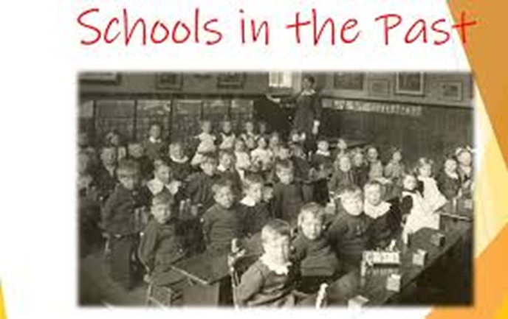

Wartime Life | When your grandparents were little | When your parents/carers were little | Your childhood
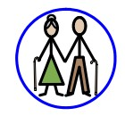
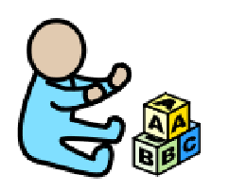

Key Concepts
Daily life  (Past times) | Know the similarities and differences between times in the past and compare to their own experiences
Links with other subjects
PSHE – relationships, growing and changing
Reading – finding information, extracting meaning, compare and contrast
Maths – time, ordering and sequencing
History – Quarry Bank Mill school room

