What should I already know?  - How old I am.  - That my parents and grandparents are older than me.  - I may have siblings that are younger than me  - Schools were different in the past but some things were similar  - Hospitals were different in the past but some things were similar | What will I find out by the end of the unit?  - Know a decade is 10 years  - Times were slightly different when my parents/carers were little  - Times were very different when my grandparents were little  - Know some of the similarities and differences between their lives and those of adults around them  - There was a time before my grandparents  - were born.  - Life was very different then  - People wore different clothes, travelled in different ways, played with different toys, went on different holidays and school was very different too.  - Shops were different and supermarkets did not exist  - Technology has changed how people pay | Vocabulary  after later in time than, or behind in order  before at an earlier time; in the past  century equal to one hundred years  chronology the order of events in time  differences the condition of being different from or not like  during throughout the entire time of  new having recently arrived, been produced, or come into being  now at this time or in these times  old having existed for many years; not new.  older having lived for many years  past having happened or gone by at an earlier time  present existing at this time; current  sibling a sister or a brother  similarity likeness  slightly a small amount; a little  technology devices which are the result of scientific knowledge being used for practical purposes.  then soon after; next  usually most common or expected  younger earlier stage of life
Historical Skills and Enquiry
- Create a timeline showing key family events, and then use words such as before, after, past, present, then and now to describe their chronology.
- Describe what life was like when your parents/carers were little and what the similarities and differences are.
- Describe what life was like when your grandparents were little and what the similarities and differences are.
- Describe how Alderley Edge has changed over the last century
- Describe how technology has changed over the last decades - interview your parents/carers and grandparents and ask them what they do now that they couldn’t do before
- Research some things that happened before your parents/ carers were born and place these on your timeline.
- Research some things that happened before your grandparents were born and place these on your timeline.

 | 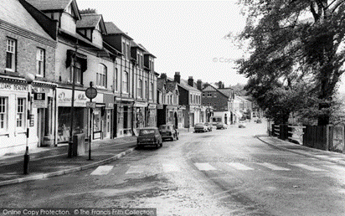

Wartime Life | When your grandparents were little | When your parents/carers were little | Your childhood
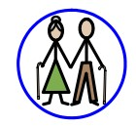
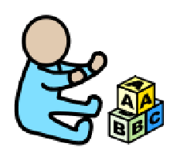

Key Concepts
Daily life  (Past times) | Know the similarities and differences between times in the past and compare to their own experiences
Links with other subjects
PSHE – relationships, growing and changing
Geography – hot and cold climates, contrasting locality (seaside)
Reading – finding information, extracting meaning, compare and contrast
Maths – time, ordering and sequencing

