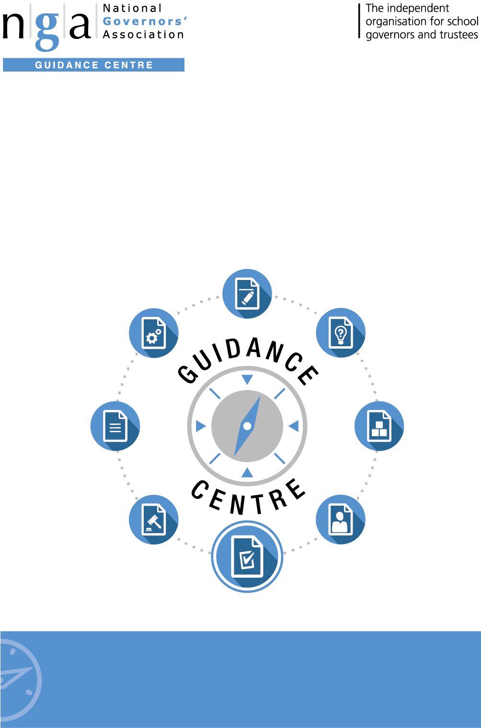

Tools and Checklists:

Maintained Governing Body Delegation Planner

Improving your governing board
Need advice?
For advice on any issue, Gold members have access to GOLDline legal advice
9 –5pm weekdays. Find out more T: 0121 237 3782 www.nga.org.uk/goldline

Need advice?
For advice on any issue, Gold members have access to GOLDline legal advice
9 –5pm weekdays. Find out more T: 0121 237 3782 www.nga.org.uk/goldline

National Governors’ Association
The National Governors’ Association (NGA) is an independent charity representing and supporting governors, trustees and clerks in maintained schools and academies in England. The NGA’s goal is to improve the well-being of children and young people by increasing the effectiveness of governing boards and promoting high standards. It does this by providing information, guidance, research, advice and training. It also works closely with, and lobbies, UK government and educational bodies, and is the leading campaigning national membership organisation for school governors and trustees.

The NGA online Guidance Centre is the information hub for governors. It supports you in your role as a governor, giving you access to up to date guidance and advice covering all aspects of school governance, including finance; staffing; Ofsted; curriculum; special educational needs; legislation and school improvement.

Practical governance resources include sample documents; templates; checklists; information summaries; insights; case studies and much more.
To join NGA and receive regular updates, contact:
T: 0121 237 3780 | E: membership@nga.org.uk | www.nga.org.uk

Maintained Governing Body Delegation Planner

Governing bodies are accountable in law for all major decisions about the school and its future. However, this does not mean that they are required to carry out all the work themselves. Many of the tasks can and should be delegated to individuals and committees. It is vital that the decision to delegate a task/responsibility to an individual is made by the full governing body and recorded – without such a formula, the individual/committee has no power to act.

The table below sets out the major areas of responsibility for governing bodies and who they can delegate each task to; it also records where the NGA does not think that, even if a task/responsibility can be delegated, this would be good practice.

This planner shows to which level the governing body may legally delegate functions. Please note that the decision planner does not apply to academy governing bodies.

Key
Level 1: Full governing body
Level 2: A committee of the governing body
Level 3: An individual governor
Level 4: Headteacher.
Blue box Function cannot be legally carried out at this level.
Action could be undertaken by this level.
Although legally possible to delegate to this level, the NGA would not recommend it. Significant decisions, monitoring and evaluation are best undertaken by the governing body or a committee with delegated authority, not by individuals. As long as it is line with the regulations governing bodies are free to decide for themselves.

There is also space for notes relevant to your governing body – for example, you should specify which committee or individual a particular task will be delegated to.
- The governing body is responsible for the strategic direction of the school
- Committees can be given delegated authority to make decisions, monitor, evaluate and review particular plans, policies and targets. The head and staff play the major role in formulating plans, policies and targets to bring to committees or to the governing body for discussion prior to adoption by the full governing body.
- The head is responsible for internal organisation, management and control of the school and is accountable to the governing body.
- Although decisions may be delegated, the governing body as a whole remains responsible for any decision made under delegation.

Area |  | Function | Level |  |  |  | In our school, this responsibility is delegated to:
 |  |  | 1 | 2 | 3 | 4
Budgets |  | To approve the first formal budget plan each financial year (whether this can be delegated to a committee of the governing body depends on your local authority’s scheme of financial delegation) |  |  |  |  | Assets and Finance Committee then FGB (Spring/Summer)
 |  | To agree annual action plans and monitor how school premiums are spent (i.e. PE and sports premium, Year 7 numeracy and maths catch up premium, service premium and the pupil premium) |  |  |  |  | T&L - Termly
 |  | To monitor monthly expenditure |  |  |  |  | HT/Bursar
 |  | To establish a charging and remissions policy |  |  |  |  | Assets Committee
 |  | To enter into contracts (GB should agree financial limits) |  |  |  |  | See MIFP - MIFP is responsibility of Assets Committee
Staffing |  | Appoint selection panel for headteacher |  |  |  |  | Strategic Review Committee recommends then FGB appoints
 |  | Appoint selection panel for deputy head |  |  |  |  | Strategic Review Committee recommends then FGB appoints
 |  | Appoint selection panel for other members of the senior leadership team |  |  |  |  | Strategic Review Committee then FGB
 |  | Ratify or reject decisions of appointed selection panels |  |  |  |  | Strategic Review Committee recommends then FGB appoints
 |  | Appoint other teachers |  |  |  |  | HT/Governor
 |  | Appoint non-teaching staff |  |  |  |  | HT
 |  | To put in place a pay policy |  |  |  |  | Pay Review Committee
 |  | To make pay decisions in line with the pay policy and legal requirements¹ |  |  |  |  | Pay Review Committee
 |  | Dismissal of headteacher |  |  |  |  | Staff Dismissal Committee
 |  | Initial dismissal of other staff |  |  |  |  | HT
 |  | Suspending head |  |  |  |  | Chair
 |  | Suspending staff (except head) |  |  |  |  | HT
 |  | Ending suspension (head) |  |  |  |  | Staff Dismissal Committee
 |  | Ending suspension (except head) |  |  |  |  | Staff Dismissal Committee
 |  | Setting the overall staffing structure |  |  |  |  | Strategic Review Committee then FGB with HT
 |  | In voluntary and foundation schools to agree whether or not the Chief Education Officer/diocesan authority should have advisory rights |  |  |  |  | n/a
 |  | Determining dismissal payments/early retirement |  |  |  |  | Staff Dismissal Committee

 |  | To produce and maintain a central record of recruitment and vetting checks |  |  |  |  | Bursar and HT
 |  | Establish and review procedures for addressing staff discipline, conduct and grievance |  |  |  |  | Strategic Review Committee recommends then FGB appoints
Curriculum |  | Ensure National Curriculum (NC) taught to all pupils |  |  |  |  | T&L Committee
 |  | To consider any disapplication for pupil(s) |  |  |  |  | SLT Curriculum
 |  | To decide which subject options should be taught having regard to resources, and implement provision for flexibility in the curriculum (including activities outside school day) |  |  |  |  | T&L Committee
 |  | Establish and review a sex and relationships education policy (including in primary schools where the GB must decide whether to teach sex education) and ensure that parents are informed of their right to withdraw their children |  |  |  |  | T&L Committee
 |  | Provide clear advice, informed by statutory guidance, on which a strategy for careers advice and guidance can be based |  |  |  |  | HT
 |  | Responsibility for ensuring that provision of religious education (RE) meets statutory requirements and/or the requirements of any trust deed |  |  |  |  | T&L Committee

 |  | To ensure that all pupils take part in a daily act of collective worship in line with statutory requirements |  |  |  |  | HT
Extra-curricular provision |  | To decide whether to offer additional activities and what form these should take |  |  |  |  | HT
 |  | To put into place the additional services provided |  |  |  |  | HT
 |  | To decide whether to stop providing additional activities |  |  |  |  | HT
Performance management |  | To adopt and review teacher appraisal policy |  |  |  |  | Pay Review Committee
 |  | To appoint the panel to carry out the appraisal of the head teacher |  |  |  |  | Pay Review Committee
 |  | To carry out appraisal of other teachers (or delegate to line managers in the school) |  |  |  |  | HT
Discipline/ exclusions |  | To review all permanent exclusions and fixed term exclusions where the pupil is either excluded for more than 15 days in total in a term or would lose the opportunity to sit a public examination  (Can be delegated to chair/vice-chair in cases of urgency) |  |  |  |  | T&L Committee
 |  | To produce a set of written principles for the school behaviour policy and present these for consultation |  |  |  |  | Strategic Review Committee recommends then FGB approves
 |  | To draft the content of the school behaviour policy and publicise it to staff, students and parents. |  |  |  |  | HT

Admissions |  | To annually determine admission arrangements (VA and foundation schools) |  |  |  |  | n/a
 |  | To carry out consultation where changes to admission arrangements are proposed, or the governing body has not consulted on their arrangements in the last seven years (VA and foundation schools) |  |  |  |  | n/a
 |  | Admissions: application decisions (Governing bodies of VA and foundation schools must establish a dedicated admissions committee to allocate places, where they choose to delegate authority to committee level) |  |  |  |  | n/a
 |  | To establish and publish an admissions appeal timetable (VA and foundation schools) |  |  |  |  | n/a
 |  | To appeal against LA directions to admit pupil(s) (voluntary, foundation and special schools; also community and VC schools where LA is the admissions authority) |  |  |  |  | T&L Committee
Premises & insurance |  | Buildings insurance and personal liability– GB to seek advice from LA, diocese or trustees where appropriate |  |  |  |  | Assets Committee
Health & safety |  | To ensure a health and safety policy and procedures are in place |  |  |  |  | Assets Committee
 |  | To ensure that health and safety regulations are followed |  |  |  |  | HT

School organisation |  | To publish proposals to change category of school |  |  |  |  | Assets Committee
 |  | To decide whether to convert to academy status² |  |  |  |  | Strategic Review Committee recommends then FGB approve
 |  | Propose to alter voluntary foundation or foundation special school |  |  |  |  | n/a
 |  | Propose to discontinue voluntary foundation or foundation special school |  |  |  |  | n/a
 |  | To set the times of school sessions and the dates of school terms and holidays (except in community, special and VC schools where this is the LA’s role) |  |  |  |  | n/a
 |  | To ensure that school lunch nutritional standards³ are met |  |  |  |  | T&L Committee
 |  | To establish a data protection policy and review it at least every two years and register with the Information Commissioner’s Office |  |  |  |  | T&L Committee
 |  | Maintain a register of pupil attendance |  |  |  |  | HT
 |  | To ensure provision of free meals to those pupils meeting the criteria, including Universal Infant Free School Meals (if applicable) |  |  |  |  | HT

Information for parents |  | To determine whether to publish a home-school agreement (no longer a statutory requirement) |  |  |  |  | T&L Committee
 |  | Overall responsibility for ensuring that statutory requirements for information published on the school website, including details of governance arrangements, are met |  |  |  |  | T&L Committee
 |  | To establish, publish and review a complaints procedure |  |  |  |  | Strategic Review Committee recommends then FGB approves
 |  | To establish and publish a Freedom of Information scheme and ensure the school complies with it |  |  |  |  | Strategic Review Committee recommends then FGB approves
GB roles, procedures and development |  | Ensure focus on three core strategic functions:  - Ensuring clarity of vision, ethos and strategic direction  - Holding the headteacher to account for the educational performance of the school and its pupils, and the performance management of staff  - Overseeing the financial performance of the school and making sure its money is well spent |  |  |  |  | Strategic Review Committee recommends then FGB approves
 |  | To draw up an instrument of government and any amendments thereafter |  |  |  |  | Strategic Review Committee recommends then FGB approves
 |  | To appoint (and remove) the chair and vice-chair of a permanent or a temporary governing body |  |  |  |  | Strategic Review Committee recommends then FGB approves
 |  | To appoint and dismiss the clerk to governors |  |  |  |  | Strategic Review Committee recommends then FGB approves
 |  | To appoint and remove co-opted governors |  |  |  |  | Strategic Review Committee recommends then FGB approves
 |  | To appoint local authority governors |  |  |  |  | Strategic Review Committee recommends then FGB approves
 |  | To set up and publish a register of governors’ business and pecuniary interests |  |  |  |  | Strategic Review Committee
 |  | To set the structure and remit of the governing body and any committees including governor appointment details, term of office and attendance record |  |  |  |  | Strategic Review Committee recommends then FGB approves
 |  | To publish the structure and remit of the governing body and any committees including governor appointment details, term of office and attendance record |  |  |  |  | Strategic Review Committee
 |  | To submit governor information to the DfE database of governors via Edubase |  |  |  |  | Approval by FGB and submission by School
 |  | To approve and set up a governors expenses scheme |  |  |  |  | Strategic Review Committee
 |  | To consider whether or not to exercise delegation of functions to individuals or committees |  |  |  |  | Strategic Review Committee recommends then FGB approves
 |  | To regulate the GB procedures (where not set out in law) |  |  |  |  | Strategic Review Committee recommends then FGB approves

 |  | To agree governor induction and training programme |  |  |  |  | Strategic Review Committee recommends then FGB approves
 |  | To review progress against strategic plan and evaluate governing body performance |  |  |  |  | Strategic Review Committee recommends then FGB approves
Formal Collaboration |  | To consider forming or joining a group of schools |  |  |  |  | Strategic Review Committee recommends then FGB approves
Academies |  | To consider approach and time scale to academy conversion |  |  |  |  | Strategic Review Committee then FGB
 |  | To consider forming or joining an existing Multi-academy-trust (MAT) |  |  |  |  | Strategic Review Committee then FGB
Federations |  | To consider forming a federation or joining an existing federation |  |  |  |  | Strategic Review Committee then FGB
 |  | Review of structure including any subsequent conversion to MAT status |  |  |  |  | Strategic Review Committee recommends then FGB approves
Inclusion and equality |  | To establish and approve a special educational needs (SEN) policy |  |  |  |  | Strategic Review Committee recommends then FGB approves
 |  | To publish and update at least annually a SEN information report (meeting requirements set out in the Special Educational Needs and Disability Regulations 2014) |  |  |  |  | SENDCo/Governor with responsibility for SEND – approval by T&L Committee
 |  | To designate a qualified teacher to be responsible for co-ordinating SEN provision (the SEN co-ordinator or SENCO) |  |  |  |  | HT
 |  | To appoint a designated teacher for looked-after children |  |  |  |  | HT – designated person is SENDCo
 |  | To establish an accessibility plan and review it every three years |  |  |  |  | Assets Committee
Safeguarding |  | To have due regard to the need to prevent people from being drawn into terrorism and to oversee the incorporation of the necessary procedures and practices outlined in the Prevent duty into the child protection policy |  |  |  |  | Strategic Review Committee recommends then FGB approves
 |  | To adopt and review annually a child protection policy and relevant procedures |  |  |  |  | T&L Committee

Notes
- In some schools, particularly larger ones, it may be appropriate to delegate deciding pay discretions to the headteacher. However, in this case it is a good idea for the governing body to quality assure the decisions made, for example by spot checking a selection.
- Regulation 18 of the School Governance (Roles, Procedures and Allowances) (England) Regulations 2013 permits the governing body to delegate any of its functions, subject to the restrictions listed in Regulation 19. Academy conversion is not included on this list and the Academies Act 2010 explicitly restricts the functions of the discontinuance of schools provisions in the Education and Inspections Act 2006. Therefore legally the Regulations permit delegation of the decision to convert to an academy. However, it would be bad practice for any decision affecting the future of the school to be decided by anything other than the full governing body. Furthermore, it is unlikely that the Department for Education would accept an application to convert which had not been signed off by the full governing body.
- Set out in the School Food Regulations which came into force on 1 January 2015.

