What I already know
What should I already know?
- The Stone Age was when early humans used tools from stone. This is also known as pre-history.
- At the end of the Ice Age, the sea levels rose and so Britain turned into an island.
- The Stone Age had three periods - Palaeolithic (‘old’ Stone Age), Mesolithic (‘middle’ Stone Age) and Neolithic (‘new’ Stone Age).
- Palaeolithic Stone Age lasted until the end of the Ice Age. Early humans used stones as tools. This lasted till about 10, 500 BC
- Mesolithic Stone Age was from about 10, 500 BC to 4, 000 BC. Humans would demonstrate a variety of ways to gather food including hunting and fishing.
- Neolithic Stone Age was from 4, 000 BC to about 2, 500 BC. This marked the start of farming including land clearance and the keeping of animals.

Neolithic Britain: start of farming

c. 4,000 BC
-

2
,500 BC

Palaeolithic Britain: early humans
first use tools from stone

c. 800,000 BC
-

,500 BC
10

Mesolithic Britain: end of Ice Age
to start of farming

c. 10, 500 BC
-

4
, 000 BC

What will I know by the end of the topic?

Bronze Age:
- The Bronze Age started at different times around the world.
- Tools were made from bronze - copper and tin were heated up and poured into casts.
- Evidence of the Bronze Age:
- Amesbury Archer - the remains of an early Bronze Age man who was buried with over 100 artefacts
- Discovery of round barrows and stone circles
- The Bronze Age started when the Beaker People arrived from Europe.
- They brought with them new ways of making metal.
- Bronze Age people lived in settlements, which was a group of round houses.
- Houses were made from wattle (sticks) and daub (mud) or dry stone.
- Settlements traded resources like copper and tin.
- Burials were important to Bronze Age people - they placed stone circles where burials took place.

Iron Age:
- Tools were made from iron. Iron was heated up then the hot iron was hammered into shape.
- Settlements became larger because tribes were better able to farm and defend themselves.
- At the end of the Iron Age, coins were made and used as currency.
- There were lots of battles between tribes who fought each other for more land and power.
Vocabulary
archaeologist | someone who studies the past by exploring old remains
artefact | an object from the past that shows evidence of what life was like
barrow | a large structure made of earth that people used to build over graves.
believe | Bronze Age people held religious gatherings, usually around burials. Iron Age people believed in powerful spirits.
bronze | copper and tin are melted together to make a metal called bronze.
century | a period of 100 years
circa | Latin meaning ‘around’. c. 800 BC means around 800 BC.
druids | powerful religious people
gather | collect things together
hillfort | settlements built on hills to provide more protection
invasion | to try and take over a place by force
loom | an apparatus that makes fabric using threads
migration | movement from one place to another in order to settle there
rampart | a defensive wall built for protection
remains | traces of the past
resources | something used to help when needed. Resources are usually traded.
sacrifice | offerings to spirits such as weapons, animals and humans
settler/ settlement | people who migrate to a new place. When people start a community, this is a settlement
stone circle | burials took place in stone circles.
trade | the activity of buying, selling, or exchanging goods or services
variety | things which are different from each other
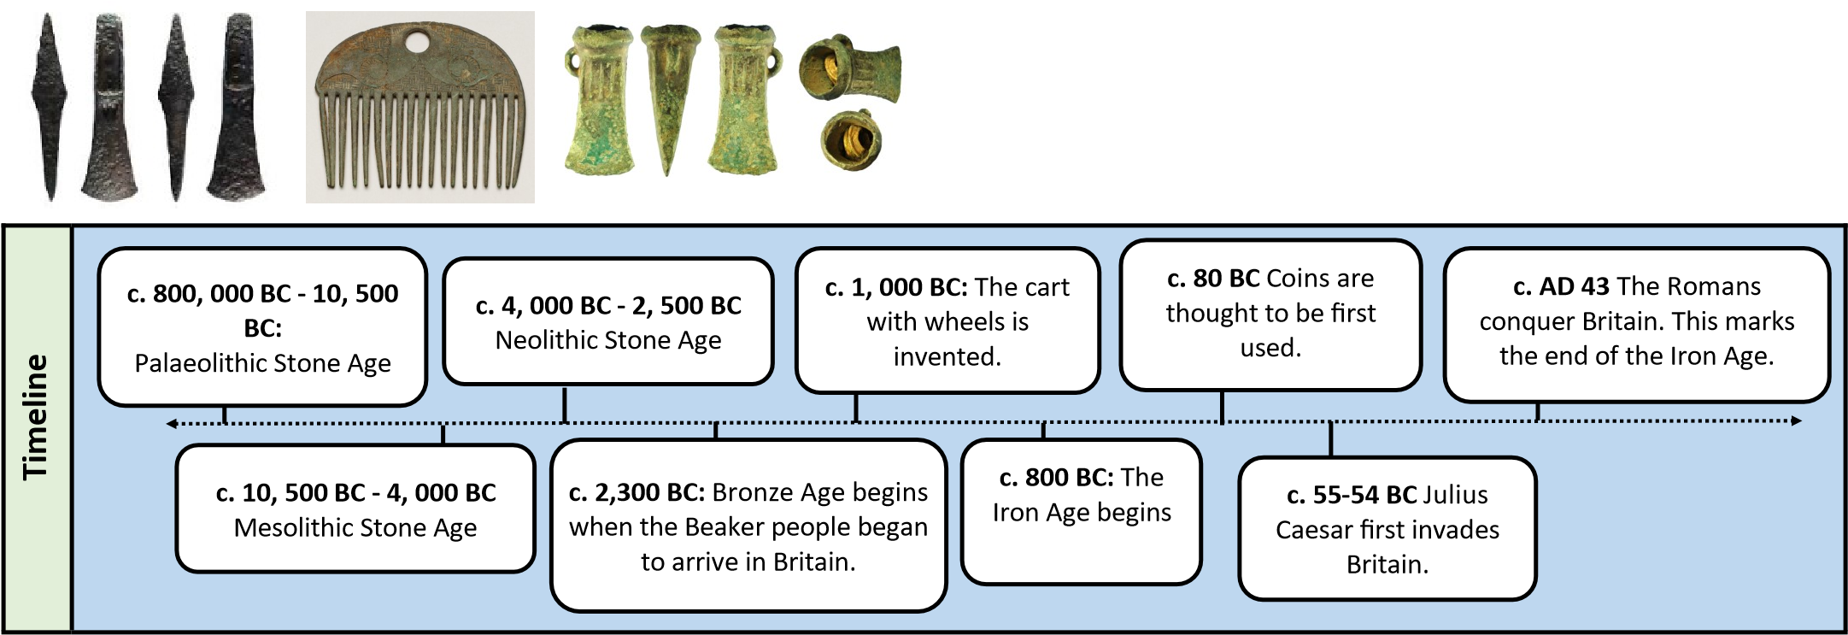
Historical enquiry skills I will develop
- Describe what life was like for all groups of people during the Bronze and Iron Ages.
- Ask questions and find out the answers about the Bronze and Iron Ages.
- Explain how Britain changed during the Bronze and Iron Ages using a timeline to help.
- Explain how we know about the Bronze and Iron Ages.
- Study Bronze and Iron Age artefacts/tools and explain what their uses were.
- Place events on a timeline using dates
- Compare the Stone, Bronze and Iron Ages using a Venn diagram. • Explain what religious beliefs were during this time.
- Explain how the Roman invasion brought an end to the Iron Age.
- Present what you know about the Bronze and Iron Ages using a variety of skills (e.g. Geography English, Maths, Computing) Describe what life was like during the three stages of the Stone Age - use a Venn diagram to show similarities and differences.
- Understand the meaning behind the words, Palaeolithic, Mesolithic and Neolithic.

