Alderley Edge Community Primary School
TOPIC: What is island like like? | Strand: Place Knowledge / Human and Physical Geography | Year 2
What I should already know
- There are seven continents, including Asia and Europe, and five oceans.
- The village I live in is called Alderley Edge.
- Alderley Edge is in England, which is in the UK. The UK is in the continent of Europe.
- The coast is where the sea meets land
- Weather is short term and climate is long term
- Weather and climate influence human and physical activity
What will I know at the end of the topic?
- What an island is
- The United Kingdom is in Europe and is an island
- The British Isles is a made up of lots of islands
- Greenland is the world’s largest island
- The human and physical features of islands –Orkney and Cape Verde islands
- There are similarities and differences between islands
- The climate and weather of different islands influences the type of vegetation and animals
- The weather and climate influences type if human activity including farming, tourism and leisure
Vocabulary
city | a large town. London is a city.
climate | weather that is typical of a place
coast | Where land meets the sea
continent | a very large area of land that consists of many countries. Europe is a continent.
country | an area of land that is controlled by its own government.
farming | Using the land to grow crops and animals
human features | features of land that have been impacted by human activity
island | land with water all around with no other border up to a certain size
landscape | everything you can see when you look across an area of land, including hills, rivers, buildings, trees, and plants.
physical features | natural features of land
rainfall | the amount of rain that falls in a time period
seasons | main periods of the year that can have their own weather conditions
temperature | a measure of how hot or cold something is
tourist | a person who is visiting a place for pleasure and interest, especially when they are on holiday.
town | a large group of houses, shops and buildings where people live and work. Towns are larger than villages but smaller than cities. Sudbury is a town.
vegetation | plants, trees and flowers
weather | Short term changes in temperature and rainfall
Physical Geographical Features of Islands
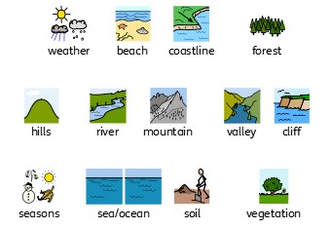

Human Geographical Features of Islands
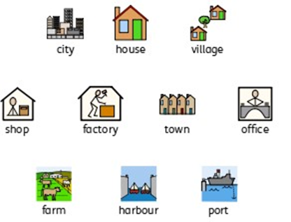

Geographical Skills and Fieldwork
- Use aerial photographs to compare Orkney and Cape Verde islands . What is the same? What is different?
- Use an atlas to locate different islands. Can you give instructions on how to use an atlas?

