Alderley Edge Community Primary School
TOPIC: Biomes (Deserts and Polar regions) | Strand: Human and Physical Geography (Concept: Biomes) | Year 1
What should I already know?
- UK in is Europe and Kenya is in Africa
- The names of a variety of common wild and garden plants, including deciduous and evergreen trees.
- The climates of Kenya in the continent of Africa and the UK in the continent of Europe.
- That there are 4 seasons in UK – summer, autumn, winter and spring
Geographical Knowledge, Skills and Fieldwork by the end of topic
- Use maps, atlases and globes to polar and desert biomes. What do you notice about the colours used to identify deserts, and polar?
- Label maps to show where biomes can be located.
- Describe what the vegetation is like in each biome.
- Complete a table to show what the biomes are in different parts of the world (e.g. Sahara desert in Africa and Artic Circle)
- Describe the relationship between biomes and climate zones.
- Research the annual temperature and rainfall in different biomes and show it in a graph
- Know some of the animals and plants that will live in the biome
- That the polar region only has 2 seasons – winter and summer
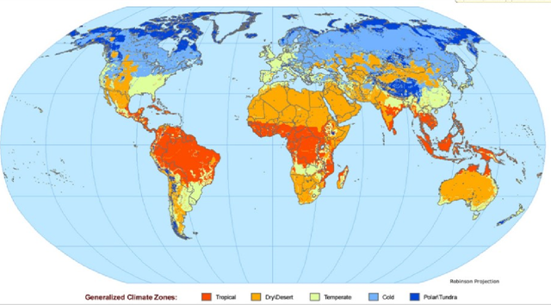
desert
polar tundra
 | Vocabulary
biome | a natural area of the living world which has its own climate, vegetation and animals
climate | the general weather conditions that are typical of a place
climate zone | sections of the Earth that are divided according to the climate. There are three main climate zones; polar, temperate and tropical.
continent | a very large area of land that consists of many countries. Europe is a continent.
deciduous | a tree that loses its leaves in the autumn every year
desert | a large area of land, usually in a hot region, where there is almost no water, rain or vegetation
equator | an imaginary line around the middle of the Earth at an equal distance from the North Pole and the South Pole.
evergreen | a tree or bush which has green leaves all the year round
forest | a large area where trees grow close together
globe | a ball-shaped object with a map of the world on it
humid | a climate that is very hot and damp
ice | Frozen water
ocean | one of the five very large areas of salt water on the Earth's surface.
poles | the two opposite ends of Earth at its most northern and southern points
polar | Large areas of land and sea around the north and south poles
rainfall | the amount of rain that falls in a time period
temperature | a measure of how hot or cold something is
vegetation | plants, trees and flowers
wild | animals or plants that live or grow in natural surroundings and are not looked after by people

Biome | Typical Climate | Image | Example of location
desert | dry all year round  can be hot or cold | 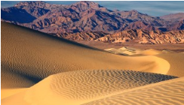 | North Africa, Central Australia
polar regions | Cold and windy all year round | 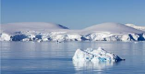 | North and south poles

