Alderley Edge Community Primary School
TOPIC: My Class, My School, My Road | Strand: Geographical skills and field work | Year 1
Aerial view of school grounds
playground
hall
environmental area
main building
field
 | What should I already know?
• | My classroom layout.
• | Where key areas in the school are (hall, office, my classroom)
• | My route to school.

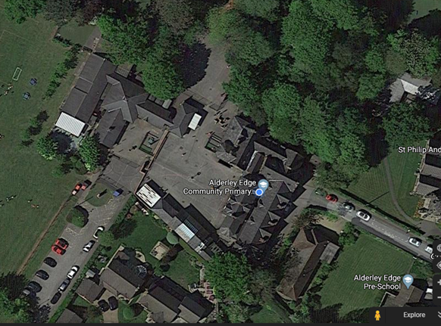
Squirrel Club
Geographical Skills and Fieldwork
- Label an aerial view picture of your classroom to show where everything is.
- Label an aerial view floor plan of the school.
- Write instructions about how to get from your classroom to the office.
- Study the geography of the school and its grounds and the key human and physical features of its surroundings
- Use Google Maps - locate where you live and draw your route to school over the roads seen.

What will I know by the end of the unit? |  | Vocabulary
 |  | aerial view | a view from above
- What the route from my classroom to other areas of the school looks like on a floor plan.  - What the school looks like from above and what the surrounding grounds look like.  - What the route from home to school looks like on a map.  - How to give instructions on how to get from one place to another. |  | floor plan | the layout of rooms on one floor of a building
 |  | grounds | the land around a building
 |  | human  geography | features of land that have been impacted by human activity
 |  | physical  geography | natural features of land
 |  | route | a way from one place to another
 |  | surrounded | to be present all around
 |  | village | a small group of houses, perhaps with a few shops, that are often in the countryside. Alderley Edge is a village.

