Alderley Edge Community Primary School
TOPIC: Water Cycle | Strand: Geographical processes | Year 4
What should I already know?
- Evaporation happens when water (a liquid) turns into water vapour (a gas) when it is heated.
- Condensation happens when water vapour (a gas) turns into small water droplets (liquid) when it is cooled.
- Plants absorb water through the soil to help them grow
- Climate regions of mountains
- Features of mountains and rivers
Geographical Skills and Fieldwork
- Present what you know about the water cycle using a variety of skills using appropriate vocabulary.
- Observe evaporation and condensation in action by using bowls of water and mirrors /glass.

The Water Cycle  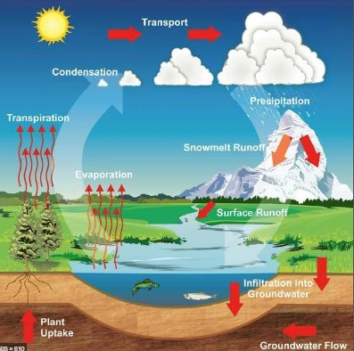 | Vocabulary  absorb soak up or take in  atmosphere the layer of air or other gases around a planet  condensation small drops of water which form when water vapour or steam touches a cold surface, such as a window  evaporation to turn from liquid into gas; pass away in the form of vapour.  gas a form of matter that is neither liquid nor solid. A gas rapidly spreads out when it is warmed and contracts when it is cooled.  groundwater water that is found under the ground. Groundwater has usually passed down through the soil and become trapped by rocks.  liquid in a form that flows easily and is neither a solid nor a gas.  precipitation rain, snow, sleet, dew, etc, formed by condensation of water vapour in the atmosphere  runoff rain in excess of the amount absorbed by the ground  surface the flat top part of something or the outside of it  transpiration evaporation of water from a plant's leaves, stem, or flowers  water vapour water in the gaseous state, esp when due to evaporation at a temperature below the boiling point

How Does the Water Cycle Work?
- Evaporation:
- The Sun causes the water from the Earth to evaporate.
- This water evaporates from seas, lakes, streams and even puddles.
- When it evaporates, water turns into water vapour.
- Condensation:
- As the water vapour rises, it cools down.
- As it cools down, condensation happens and water vapour condenses to small droplets of water.
- Clouds are made from a mix of dry air and small droplets of water.
- Precipitation:
- As condensation continues to happen, more droplets of water vapour are formed.
- When the droplets become heavy and large enough, they fall back to the Earth’s surface in the form of rain or snow.
- Runoff and Transpiration:
- As precipitation happens in the form of rain or snow falling back to Earth, water is absorbed into the soil.
- This water is used by plants to grow - when water from plant leaves evaporates back into the atmosphere, this is called transpiration.
- Water may also run off and enter oceans, seas and rivers.
- Water then evaporates again and the water cycle begins again!

