Alderley Edge Community Primary School
TOPIC: Volcanoes and Earthquakes | Strand: Knowledge (Human and Physical) | Year 4
What should I already know?
- The seven continents and five oceans of the world.
- The location of some countries, including the UK and Kenya.
- What climate means and how it effects the vegetation in an area
- Greece is in Europe and some of the physical and human geography of Greece linked to place topic
- When two tectonic plates of the earth's crust grind into each other the land can be pushed upwards, forming mountains.
- Many of the greatest mountain ranges of the world have formed because of enormous collisions between the tectonic plates.
- When many mountains are close together, this is called a range.
- The highest point of a mountain is called the peak or the summit.
Features of Cheshire and Greece
 | Human features | Physical features
Cheshire | Cheshire has many villages (such as Alderley Edge) and towns (such as Macclesfield). There are no official cities in Cheshire East but our nearest city is Manchester  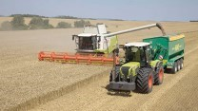  Cheshire has many farms and is famous for the farming trade.  Cheshire has salt mines  Cheshire is famous for Cheshire Cheese  Historically Macclesfield was famous for silk | River - River Bollin which is a tributary to the River Mersey into the Irish Sea  Highest point – Shining Tor on border between Cheshire and Derbyshire  The landscape is green as there are many fields.  The climate is mild. The summers are warm and the winters are cool.  Cheshire's natural hazards include floods
Greece | Greece has many villages, towns and cities. The capital city in Greece is Athens, which is a port city.  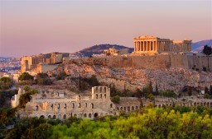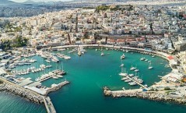  Greek ferries are the primary means of transport to and from the islands.  Many tourists visit Greece, especially Athens and the islands.  Greece’s main exports include petrol and food, such as olive oil and fish.  Greece has many ancient structures, including the Acropolis and the Delphi. | Greece is a mountainous country with a very long coastline, made up by a mainland, peninsulas and islands.  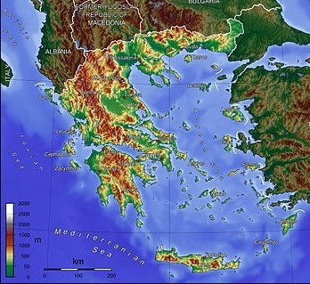  Greece's natural hazards include severe earthquakes, floods, droughts and wildfires. Current environmental issues include air pollution and water pollution.  Mount Etna, Europe’s largest volcano is in Greece

What will I know be the end of the topic?
Volcanoes
- A volcano is a very deep hole in the Earth’s top layer that can let out hot gasses, ash and lava. Many volcanoes are also mountains.
- Volcanoes have long vents that go all the way down through the Earth’s first layer, the crust, to magma in between the crust and the mantle (the Earth’s second layer). It’s so hot there that rocks melt into liquid. This is called magma, which travels up through volcanoes and flows out as lava.
- There are three ways to describe a volcano and explain what it’s doing – active, erupting, and dormant
- When a volcano erupts, magma comes up and out through the vents. Magma is called lava when it’s outside the volcano.
- Some volcanoes are underwater.
- There are no volcanoes in the UK. The largest volcano in Europe is Mount Etna in Greece

Vocabulary
active | An active volcano has erupted recently or is expected to erupt quite soon
climate | the general weather conditions that are typical of a place
continent | a very large area of land that consists of many countries. Europe is a continent.
core | the central part of the earth, beneath the mantle
crust | The Earth's crust is its outer layer
dormant | not active but is capable of becoming active later on
earthquake | a shaking of the ground caused by movement of the Earth's crust
erupt | When a volcano erupts, it throws out a lot of hot, melted rock called lava, as well as ash and steam
fault lines | a long crack in the surface of the earth. Earthquakes usually occur along fault lines
form | move or arrange
gas | something that is neither liquid nor solid. A gas rapidly spreads out when it is warmed and contracts when it is cooled.
lava | the very hot liquid rock that comes out of a volcano
layers | If something has many layers, it has many different levels or parts
location | the place where something happens or is situated
magma | molten rock that is formed in very hot conditions inside the earth
mantle | the part of the earth between the crust and the core
melt | to change from a solid to a liquid state through heat or pressure
molten | Molten rock, metal, or glass has been heated to a very high temperature and has become a hot, thick liquid
mountain | a very high area of land with steep sides
peak | the highest point of a mountain, Also known as a summit.
pressure | force that you produce when you press hard on something
range (mountains) | A range of mountains or hills is a line of them
summit | the highest point of a mountain, Also known as a peak.
tectonic plate | Huge slabs of the Earth’s crust that fit together like a jigsaw puzzle
Earthquakes
- The tectonic plates have edges and sometimes the edges, which are called fault lines, can get stuck, but the plates keep moving.
- Pressure slowly starts to build up where the edges are stuck and, once the pressure gets strong enough, the plates will suddenly move causing an earthquake.

The Earth
- The Earth has three layers – the crust at the very top, then the mantle, then the core at the very middle of the planet.
- The Earth's crust is made up of huge slabs called tectonic plates, which fit together like a jigsaw puzzle.
- These tectonic plates slowly move over a long period of time

