Alderley Edge Community Primary School
TOPIC: Biomes – Mediterranean | Strand: Human and Physical Geography (Concept: Biomes) | Year 4
What should I already know?
- The seven continents and five oceans.
- The names of a variety of common wild and garden plants, including deciduous and evergreen trees
- Features of the polar, desert, temperate and tropical biomes
- The climates of Kenya in the continent of Africa, China in Asia and the UK in the continent of Europe
- Climates of island life in Orkneys and Cape Verde
- Climates of mountain environments
Geographical Skills and Fieldwork
- Use maps, atlases and globes to identify different biomes. What do you notice about the colours used to identify Mediterranean climates?
- Label maps to show where Mediterranean biomes can be located.
- Describe what the vegetation is like in Mediterranean biomes
- Complete a table to show where the Mediterranean biomes are in different parts of the world).
- Describe the relationship between the biomes and climate zones.
- Research the annual rainfall in temperate biomes and show it in a graph.
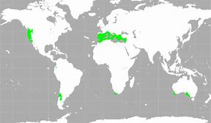
Mediterranean
 | Vocabulary
biome | a natural area of the living world which has its own climate, vegetation and animals
climate | the general weather conditions that are typical of a place
climate zone | sections of the Earth that are divided according to the climate. There are three main climate zones; polar, temperate and tropical.
continent | a very large area of land that consists of many countries. Europe is a continent.
deciduous | a tree that loses its leaves in the autumn every year
desert | a large area of land, usually in a hot region, where there is almost no water, rain or vegetation
equator | an imaginary line around the middle of the Earth at an equal distance from the North Pole and the South Pole.
evergreen | a tree or bush which has green leaves all the year round
forest | a large area where trees grow close together
globe | a ball-shaped object with a map of the world on it
grassland | a large area covered by wild grass
humid | a climate that is very hot and damp
ocean | one of the five very large areas of salt water on the Earth's surface.
poles | the two opposite ends of Earth at its most northern and southern points
rainfall | the amount of rain that falls in a time period
rainforest | a thick forest of tall trees which is found in tropical areas
temperate | a place which is never extremely hot or extremely cold
temperature | a measure of how hot or cold something is
tropical | The tropics have a humid climate, where the weather is hot and damp. They are near the equator.
tundra | a flat layer of land where the top layer is frozen. There is hardly any vegetation.
vegetation | plants, trees and flowers
wild | animals or plants that live or grow in natural surroundings and are not looked after by people

Biome | Typical Climate | Image | Example of location
temperate | Never extremely hot or cold | 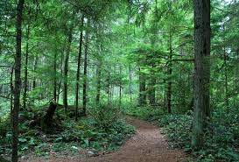 | UK, central USA, northern Europe
desert | dry all year round | 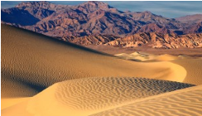 | North Africa, Central Australia
tropical | hot, humid and wet all year round | 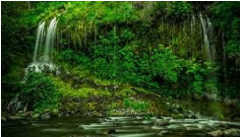 | South America
Mediterranean | Long hot summers, cool drier winters | 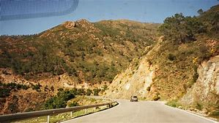 | Southern Europe

