Alderley Edge Community Primary School
TOPIC: Rivers | Strand: Knowledge (Human and Physical) | Year 3
What should I already know?
- The country I live in is called England.
- I live in Alderley Edge, which is a in England. It is near Manchester , which is a city.
- The similarities and differences between Alderley Edge and Manchester.
- England is a country in the United Kingdom (England, Scotland, Wales and Northern Ireland).
- London is the capital city of England. There are similarities and differences Alderley Edge and London.
What will I know be the end of the topic?
- All rivers start at the highest point in an area.
- As the river flows downstream, it gains more water from other streams, rivers, springs, added rainfall, and other water sources.
- A river is freshwater flowing across the surface of the land, usually to the sea.
- Rivers flow in channels. The bottom of the channel is called the bed and the sides of the channel are called the banks.
- Rivers begin at their source in higher ground such as mountains or hills, where rain water or melting snow collects and forms tiny streams.
- When one stream meets another and they merge together, the smaller stream is known as a tributary. It takes many tributary streams to form a river.
- A river grows larger as it collects water from more tributaries along its course.
- The great majority of rivers eventually flow into a larger body of water, like an ocean, sea, or large lake. The end of the river is called the mouth.
- Most settlements were built along major rivers. Rivers provide us with food, energy, recreation, transportation routes, and of course water for irrigation and for drinking.
- To know why rivers are important
- To know what causes river pollution

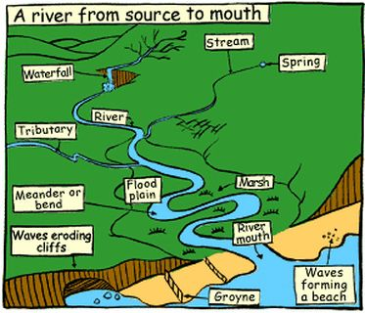

Geographical Skills and Fieldwork
- Primary evidence- river study of the river Bollin, mapping the river and its features, human and physical influences
- Use atlases to located the longest rivers in the world
- Use photograpns to idenity vegetation and fauna of rivers
- Use secondary sources including the internet to research a river and identify the human and physical influences.

Vocabulary
bed | Bottom of the river
bank | side of a river
course | The path the river follows
city | a large town. Manchester is a city.
climate | the general weather conditions that are typical of a place
coastal | an area of land close to the sea
country | an area of land that is controlled by its own government.
county | a region of Britain or Ireland which has its own local government
England | a country in the United Kingdom. Alderley Edge is a village in England.
farm | an area of land used to produce crops or to breed animals and livestock.
harbour | a sheltered port so that boats can be left there safely
human features | features of land that have been impacted by human activity
landscape | everything you can see when you look across an area of land, including hills, rivers, buildings, trees, and plants.
meander | Bend in the river
mouth | Where the river ends
physical features | natural features of land
port | a harbour area where ships load and unload goods or passengers
river | a large, natural stream of fresh water that flows into the sea or a lake.
settlement | Place where people live
sea | a large area of salty water that is part of an ocean
source | Where water comes from / start of the river
town | a large group of houses, shops and buildings where people live and work. Towns are larger than villages but smaller than cities. Sudbury is a town.
tributary | One river or stream flowing into another
River | Country | Length
River Nile | Egypt | 6693 km
River Amazon | Brazil | 6436 km
River Yangtze | China | 6378 km
River Severn | England | 354 km

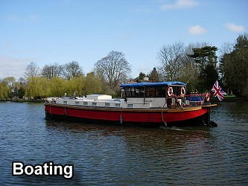
Importance of rivers
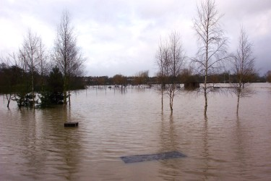
Flooding
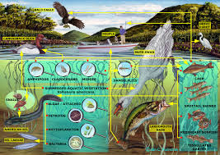
Habitat
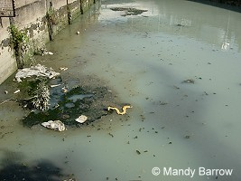
Pollution

