Alderley Edge Community Primary School
TOPIC: Mountains | Strand: Knowledge (Human and Physical) | Year 3
What should I already know?
- The seven continents and five oceans of the world.
- The location of some countries, including the UK and China
- What climate means and how it effects the vegetation in an area

Features of UK and China
 | Physical features
UK | 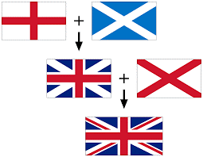  The United Kingdom is made up of 4 countries – England, Scotland Wales and Northern Island  The United Kingdom is in Europe  London is the captain of England  Ben Nevis in Scotland is the highest mountain in the UK  The River Severn is the longest river in the UK  The UK is an island surrounded by sea
China | China is in Asia.  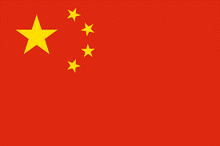  China are made up of villages, towns and cities.  China is much larger than the UK.  Beijing is the capital city of China  Mount Everest is in China  The Yangtze is the longest river is China

What will I know be the end of the topic?
Mountains
- When two tectonic plates of the earth's crust grind into each other the land can be pushed upwards, forming mountains.
- Many of the greatest mountain ranges of the world have formed because of enormous collisions between the tectonic plates.
- When many mountains are close together, this is called a range.
- The highest point of a mountain is called the peak or the summit.
- The name of the highest mountains in the world and UK
- What it is like to live in a mountain environment
- What can live on a mountain – flora and fauna

Geographical Skills and Fieldwork
- Use photographs to find out information about moutnains
- Use an atlas to located the main mountain ranges and highest peaks
- Research using the internet and non-fiction books about the climate and vegetation of different mountains to draw comparisons

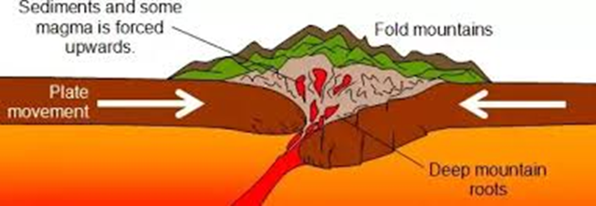
Vocabulary
base | The bottom of the mountain
climate | the general weather conditions that are typical of a place
continent | a very large area of land that consists of many countries. Europe is a continent.
crust | The Earth's crust is its outer layer
fauna | animals
flora | plants
fold mountain | Where the land has folded to form mountains
forest | Large area covered by trees
form | move or arrange
lake | a large pool of water
location | the place where something happens or is situated
mountain | a very high area of land with steep sides
peak | the highest point of a mountain, Also known as a summit.
range (mountains) | A range of mountains or hills is a line of them
summit | the highest point of a mountain, Also known as a peak.
tectonic plate | Huge slabs of the Earth’s crust that fit together like a jigsaw puzzle
valley | A v shape between 2 mountains
Mountain | Country | Height
Mount Everest | China/Nepal | 8850m
K2 | China/Pakistan | 8670m
Mount Kilimanjaro | Kenya | 5895m
Mount Vesuvius | Italy | 1281 m
Ben Nevis | UK | 1395m

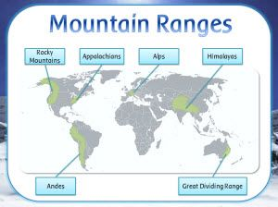

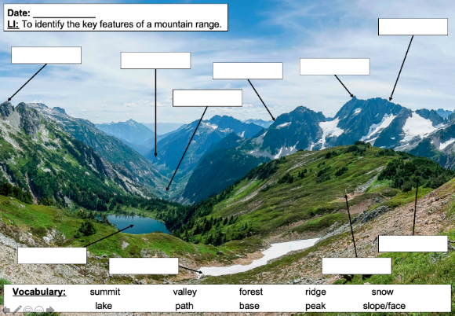
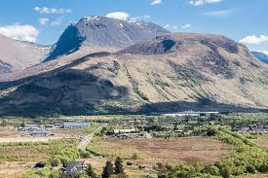
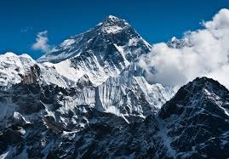
Ben Nevis
Mount Everest

