Alderley Edge Community Primary School
TOPIC: Europe | Strand: Place / Knowledge (Human and Physical) | Year 4
Features of Cheshire and Greece
 | Human features | Physical features
Cheshire | Cheshire has many villages (such as Alderley Edge) and towns (such as Macclesfield). There are no official cities in Cheshire East but our nearest city is Manchester  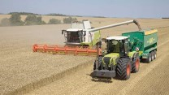  Cheshire has many farms and is famous for the farming trade.  Cheshire has salt mines  Cheshire is famous for Cheshire Cheese  Historically Macclesfield was famous for silk | River - River Bollin which is a tributary to the River Mersey into the Irish Sea  Highest point – Shining Tor on border between Cheshire and Derbyshire  The landscape is green as there are many fields.  The climate is mild. The summers are warm and the winters are cool.  Cheshire's natural hazards include floods
Greece | Greece has many villages, towns and cities. The capital city in Greece is Athens, which is a port city.  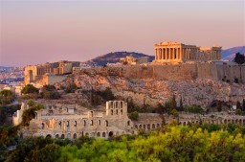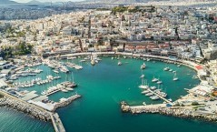  Greek ferries are the primary means of transport to and from the islands.  Many tourists visit Greece, especially Athens and the islands.  Greece’s main exports include petrol and food, such as olive oil and fish.  Greece has many ancient structures, including the Acropolis and the Delphi. | Greece is a mountainous country with a very long coastline, made up by a mainland, peninsulas and islands.  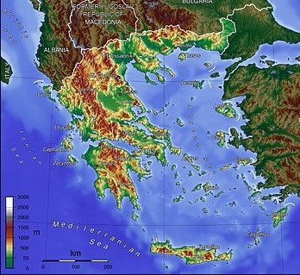  Greece's natural hazards include severe earthquakes, floods, droughts and wildfires. Current environmental issues include air pollution and water pollution.
What should I already know?
The village I live in is called Aldelrey Edge, which is in Cheshire. There are villages and towns in Cheshire
Cheshire is in England, which is a country. England, which is in the United Kingdom, is in the continent of Europe.
The seven continents (including Europe) and five oceans.
Land-use patterns of the UK.
Cheshire is surrounded by other counties such as Derbyshire, Staffordshire and Greater Manchester
Greece is in southern Europe and has a Mediterranean climate

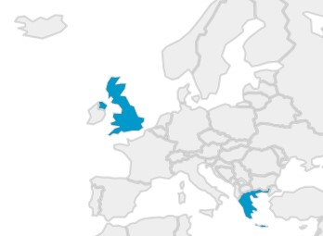
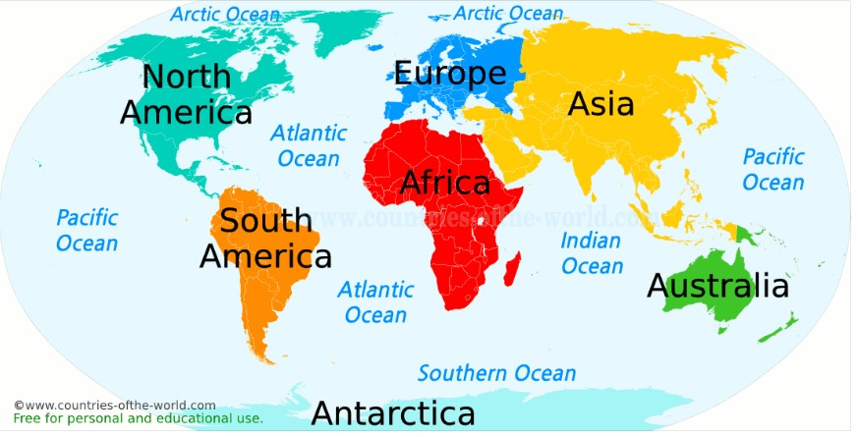
Europe

UK

Greece

also known as
Australasia or
Oceania

What will I know by the end of the unit?
- Name and locate countries in Europe including Russia, Spain, Germany, Norway, Italy and France
- Know some of the main human and physical features of each country
- The names of some of the capital cities in larger European counties
- The names and locations of the main seas – North Sea and Mediterranean
- The names and locations of the main mountain ranges – Alps, Apennine and Scandinavian (Scandes)
- Main rivers and locations – Danube, Volga and Rhine
- Know that Europe is a land mass and the European Union is political. UK is leaving/left the European Union but not the continent of Europe
- The climatic region of the country – temperate or Mediterranean
Vocabulary
architecture | planning, designing, and constructing buildings.
city | a large town. London is a city.
climate | the general weather conditions that are typical of a place
coastal | an area of land close to the sea
compass points | any of the main points of a compass: north, south, east, west, north-east, north-west, south-east, south-west
continent | a very large area of land that consists of many countries. Europe is a continent.
export | goods that are sold to other countries
harbour | a sheltered port so that boats can be left there safely
human features | features of land that have been impacted by human activity
island | a piece of land that is completely surrounded by water
landscape | everything you can see when you look across an area of land, including hills, rivers, buildings, trees, and plants.
mainland | the largest part of a country or continent is the mainland when contrasting it with the islands around it
migration | movement from one place to another in order to settle there
mountain | a very high area of land with steep sides
peninsula | a piece of land almost surrounded by water
physical features | natural features of land
river | a large, natural stream of fresh water that flows into the sea or a lake.
tourist | a person who is visiting a place for pleasure and interest, especially when they are on holiday.
trade | the activity of buying, selling or exchanging goods and services
weather | the condition of the atmosphere in one area at a particular
village | a small group of houses, perhaps with a few shops.

Geographical Skills and Fieldwork
- Use aerial photographs and research to compare countries in Europe. What is the same? What is different?
- Describe the locations of country in Europe using the eight compass points.
- Identify and describe how the physical features affect the human activity within a location.
- Study physical maps of country and label them to show the main physical features. Use this knowledge to explain the land-use patterns of country.
- Study tourism and leisure and reasons why.
- Create a Venn diagram to compare similarities and differences between 3 countries and understand the reasons for these.

