Alderley Edge Community Primary School
TOPIC: Rainforest | Strand: Place / Knowledge (Human and Physical) | Year 6
What should I already know?
- The seven continents and five oceans.
- The names of some key rivers around the world including the Thames and the Nile.
- The main biomes and climate zones around the world, including tropical
- The climate of South America and how it differs to the UK.
- Some of the human and physical features of Brazil.
- The climate of places is affected by their location (e.g. the equator, Tropics).
- The effects of climate change and pollution on the Earth.
- Which good some countries trade, and Cheshire’s biggest exports.
 | Vocabulary
biome | a natural area of the living world which has its own climate, vegetation and animals
climate | the general weather conditions that are typical of a place
climate change | changes in the earth’s climate, especially the gradual rise in temperature, as a result of human activity
climate zone | sections of the Earth that are divided according to the climate. There are three main climate zones; polar, temperate and tropical.
deforestation | if an area is deforested, all the trees there are cut down
distribution | delivering goods to a number of places
economy | A country's economy is the wealth that it gets from business and industry
equator | an imaginary line around the middle of the Earth at an equal distance from the North Pole and the South Pole.
export | To export products or raw materials means to sell them to another country
flora | plants
fauna | animals
import | To import products or raw materials means to buy them from another country for use in your own country
global | something that happens in all parts of the world or affects all parts of the world
natural resources | the land, forests, energy sources and minerals existing naturally in a place that can be used by people
palm oil | a yellow oil which comes from the fruit of certain palm trees and is used in making soap and sometimes as a fat in cooking
pollution | the process of polluting water, air, or land, especially with poisonous chemicals
supply chain | the entire process of making and selling goods, including every stage from the supply of materials and the manufacture of the goods through to their distribution and sale
sustainability | to maintain at a steady level without exhausting natural resources or causing severe environmental damage
trade | the activity of buying, selling, or exchanging goods or services
trade route | a route, often covering long distances, that is used by traders
tropics | parts of the world that lie between two lines of latitude, the Tropic of Cancer, 23½° north of the equator, and the Tropic of Capricorn, 23½° south of the equator.  The tropics have a humid climate, where the weather is hot and damp.
vegetation | plants, trees and flowers

Geographical Skills and Fieldwork
- Use atlases, maps and aerial photographs to find rainforests and explain what the climate is like there. Explain why rainforests cannot be found in the UK.
- Label maps to show where rainforests can be located.
- Compare the average rainfall in different climate zones, including the rainforest, and draw a graph to represent this.
- Compare the sizes of different rainforests and represent them in a table.
- Explain how the vegetation and animal life changes in the different layers of the rainforest.
- Investigate the effects of climate change and pollution on rainforests. Use your knowledge to create a campaign to limit pollution and deforestation.
- Explain how deforestation can impact the Earth.
- Explain sustainability and the role rainforests play.

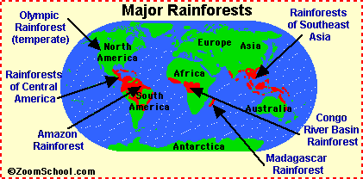
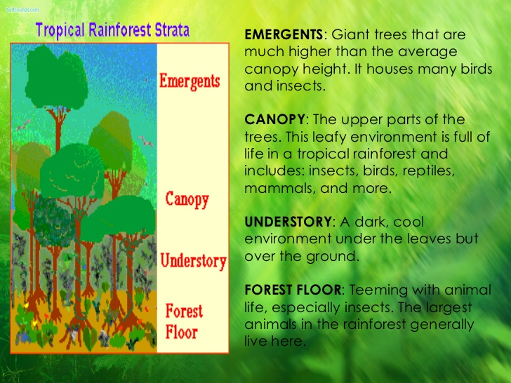
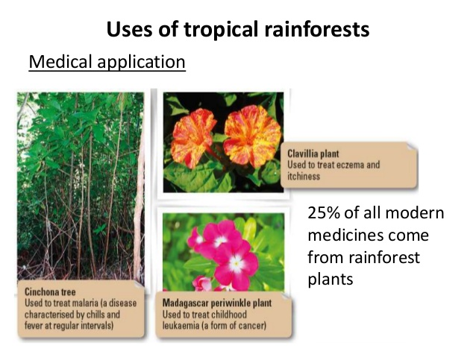
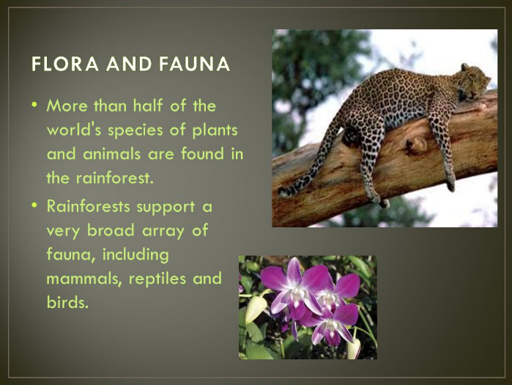
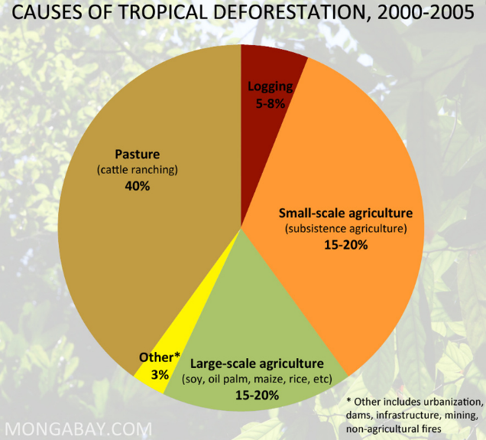
Diagrams to know and understand

