17th July2023
Parent Survey 2023

Dear Parents

We are continually working hard to improve the quality of the provision, the teaching and learning experiences and general personal development of and for children at Alderley Edge Community Primary School.

To help us in this development we would welcome your views on your child’s experience of school. We ask that you spend a short amount of your time to complete an online survey. It should take no more than 5 minutes to complete.

The survey can be accessed by clicking on the link or copying and pasting the following link in to your web browser or using the QR reader below…

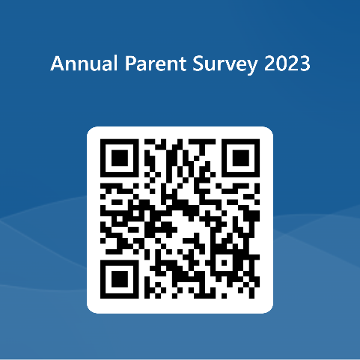
https://forms.office.com/e/P4GaABv2fr

The survey will close on September 1st 2023

We request that you submit one survey for each of your children.

I would like to take this opportunity to thank you for completing this survey. Your views are important to us and help shape the future development of the school.
Yours sincerely

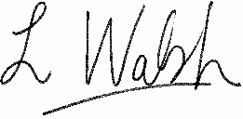
Lindsey Walsh
Head Teacher

