04 October 2023

Can You Get A Blue Peter Badge for Reading?

Dear Children and Parents,
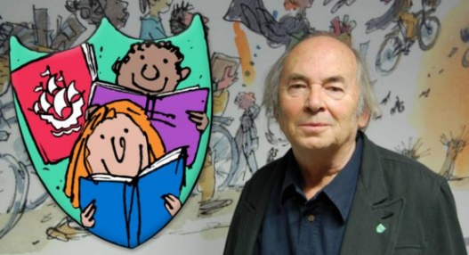
Blue Peter have released a new book badge, designed by well-known illustrator Sir Quentin Blake. To earn this book badge, it’s all about expressing your love of reading!

To earn your badge, all you need to do is share your thoughts on your favourite book. Maybe it was an action-packed adventure story, or a sci-fi mystery… whatever it is, make sure you’re sharing your love of books. This can be in a book review, a drawing of your favourite book, a painting, digital artwork or any other way you think of.

This is a competition for children aged 5-15 years old.

For more details please see the Blue Peter website - https://www.bbc.co.uk/cbbc/findoutmore/blue-peter-apply-for-a-book-badge

Make sure you’re using the online uploader form located on Blue Peter’s website (with parents or guardian’s permission). Once you do this, you will be entitled to a Blue Peter Reading badge, which will be posted to your home address from Blue Peter!

You can also apply by post and send your application with the correct postage to: Blue Peter, BBC Bridge House, MediaCityUK, Salford, M50 2BH.

This exciting opportunity is to be completed outside of school but we would love to share in your success in our Friday Celebration Assembly when you get your badge!

If you need anymore information, don’t hesitate to ask your teachers and check it out for yourself on the Blue Peter website.
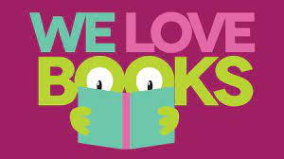
Happy reading!

Miss Hibbert

