Alderley Edge Community Primary School Staff
September 2023

Mrs Lindsey Walsh Miss Lyndsey Platt Miss Melanie Rose Mrs Lesley Sym
(Headteacher) (Deputy Headteacher) (Teacher / SENDCO) (Teacher)
Mrs Emma Gallimore Miss Louise Hilton Mrs Nikita Salt Mrs Helen Hill (Teacher) (Teacher) (Teacher) (Teacher)

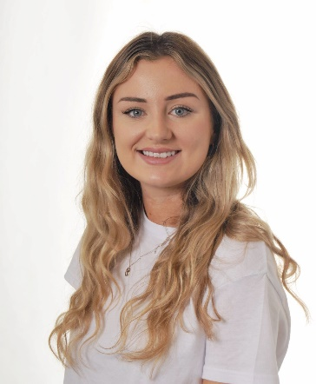
Miss Laura Hibbert Miss Julia Burnett Mrs Ruth Lewis Miss Suzie Wallace
(Teacher) (Teacher) (PE Teacher) (Learning Support Assistant/
MFL Teacher)
Mrs Suzanne Broadrick Mrs Ania Shotton Mrs Angela Aiken Mrs Rachel French
(Bursar) (Clerical Assistant) (Music Teacher) (Learning Support Assistant)
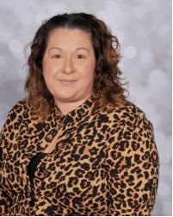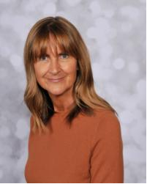
Mrs Laura Deery Miss Hannah Rowson Mrs Karen Stanbury Miss Vanessa Beech
(Learning Support Assistant) (Learning Support Assistant) (Learning Support Assistant) (Learning Support Assistant) 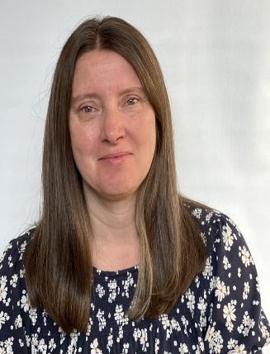 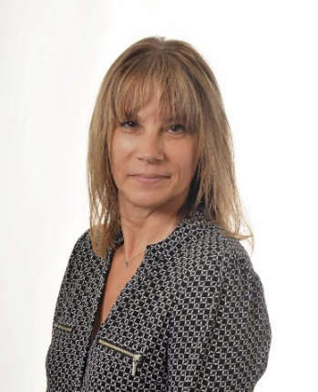
Mrs Siu Lau Mrs Julie Jackson Mrs Kathryn Reynolds Miss Leona Heeney
(Learning Support Assistant) (Learning Support Assistant) (Learning Support Assistant) (Learning Support Assistant)

Mr Tony Guest Mrs Julia Guest Miss Helen Fitchett Mrs Anne Fearn
(Midday Assistant) (Midday Assistant) (Midday Assistant) (Midday Assistant
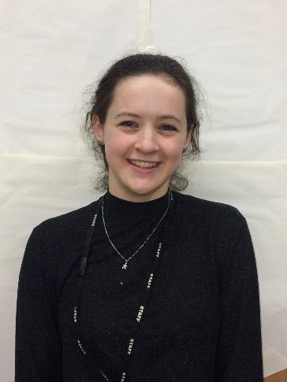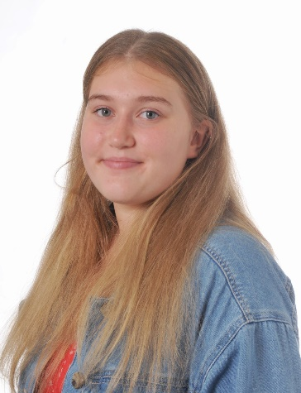
Mrs Ruth Share Mrs Jackie Burt Miss Libby Hamilton Miss Mia Share
(Squirrel Club Deputy Manager) ( Site Manager) (Playworker) (Playworker)

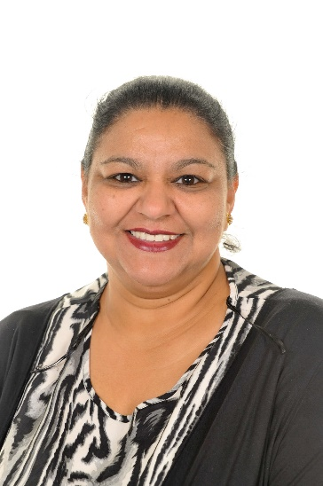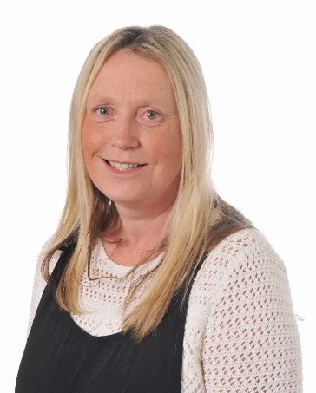
Mrs Ann Singh Mr Andrew Gregory Miss Joanne Gregory
(Playworker) (Supply Teacher) (Midday Assistant/Playworker)

