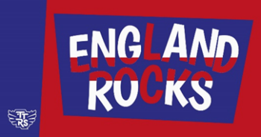
Wednesday 09 November 2023

Dear parent/carer,

As part of our commitment to make maths exciting and high profile in our school and our celebrations of Maths Week England, we are taking part in a friendly competition involving schools in England. The competition runs from 07:30 GMT Tuesday 14th November 2023 to 19:30 GMT Thursday 16th November 2023. It's all done online via play.ttrockstars.com.

Last year, the school placed within the top 200 primary schools in the country. This was an incredible achievement as thousands of schools entered. It would be wonderful to try and match or exceed this achievement again this year. There will be certificates and prizes for the top three players in each class and a reward for the best achieving class in the school.

Children can play in any game mode with every correct answer to a multiplication or division question, earning themselves, their class and the school a point. The Times Tables Rock Stars platform will calculate the class average (the number of correct answers per pupil in the class who play during the competition hours, subject to a daily 60-minute limit (see below)). Winning classes in the school and in the competition as a whole will be the ones with the highest average.

To support player wellbeing, there is a daily time limit of 60-minutes per player. In other words, each player can earn competition points for up to 60-minutes between 07:30 GMT and 19:30 GMT on 07:30 GMT Tuesday 14th November 2023 to 19:30 GMT Thursday 16th November 2023. Once the player goes beyond 60-minutes of play on that day, they will still earn coins but will no longer earn points towards the competition.

In the spirit of the competition, please don't play on their behalf but by all means encourage and support them to the extent that it doesn't cause high stress levels or impact on family plans.

Kind Regards

Miss J Burnett

