14 December 2023

YOUR VIEWS COUNT – Parent questionnaire about homework

Dear Parents

Homework is always a contentious issue in schools. Some parents want lots whilst others don’t want any! This is the same in schools across the country.

The school’s homework policy is currently being reviewed by the Governors. The views of parents matters when shaping policy and practise regarding homework.

Please can you complete the online questionnaire so we can understand the feelings of the parental community regarding homework by clicking on the link below:

Homework Survey 2024

Please complete one questionnaire for each of your children as your views may be may be different depending on the age of the child.

The deadline for the questionnaire has been set for Monday 15th January 2024.

Many thanks for taking time to support us by completing this survey.

Kind regards

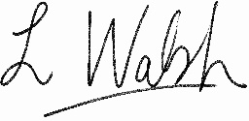

Lindsey Walsh
Head Teacher

