
Alderley Edge Community Primary School Staff
March 2025


Mrs Lindsey Walsh Miss Lyndsey Platt Miss Melanie Rose Mrs Lesley Sym
(Headteacher) (Deputy Headteacher) (Teacher / SENDCO) (Teacher)

Mrs Emma Gallimore Mrs Rowley Louise Mrs Nikita Salt Miss Elsha Rushe (Teacher) (Teacher) (Teacher) (Teacher)

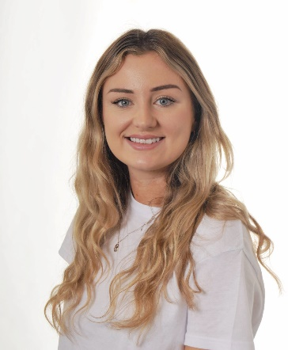
Miss Laura Hibbert Miss Julia Burnett Mrs Ruth Lewis Miss Suzie Wallace
(Teacher) (Teacher) (PE Teacher) (Learning Support Assistant/
MFL Teacher)
    Mrs Suzy Broadrick Mrs Ania Shotton Mrs Angela Aiken Mrs Rachel French
(Bursar) (Clerical Assistant) (Music Teacher) (Learning Support Assistant)

Miss Sarah Trust Miss Hannah Rowson Mrs Karen Stanbury Mrs Vanessa Lamb
(Learning Support Assistant) (Learning Support Assistant) (Learning Support Assistant) (Learning Support Assistant) 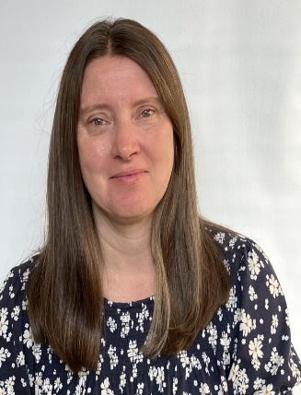 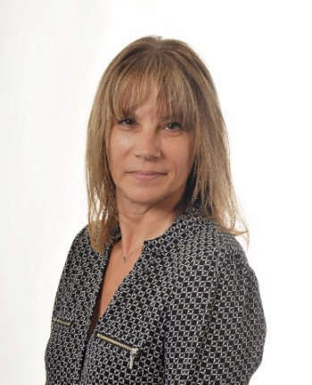 
Mrs Siu Lau Mrs Julie Jackson Mrs Kathryn Reynolds Miss Leona Heeney
(Learning Support Assistant) (Learning Support Assistant) (Learning Support Assistant) (Learning Support Assistant)

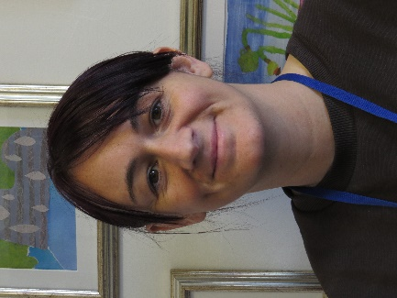
Miss Helen Fitchett Mrs Anne Fearn Miss Diane Booth
(Midday Assistant) (Midday Assistant) (Midday Assistant)

Mrs Ruth Share Mrs Joanne Vanden Mr Tibor Balogh
(Squirrel Club Deputy Manager (Learning Support Assistant) (Site Manager)

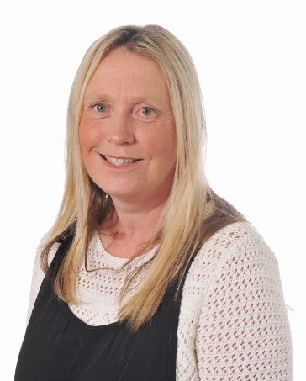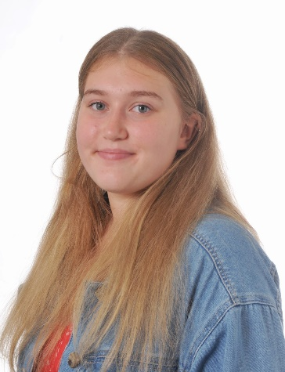
Mrs Ann Singh Mrs Joanne Aymes Miss Mia Share
(Playworker) ( Midday Assistant/Playworker) ( Playworker)

