
Alderley Edge Community Primary School Staff
September 2025


Mrs Lindsey Walsh Miss Lyndsey Platt Mrs Lesley Sym
(Headteacher) (Deputy Headteacher) (Teacher)

Mrs Emma Gallimore Mrs Rowley Louise Mrs Nikita Salt Miss Elsha Rushe (Teacher) (Teacher) (Teacher) (Teacher)

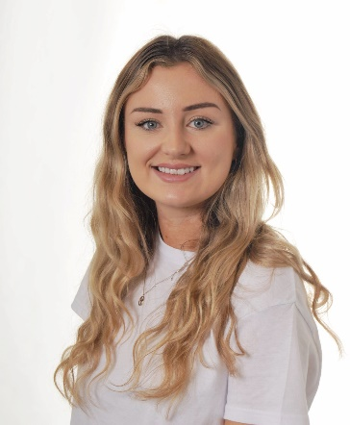
Miss Laura Hibbert Miss Julia Burnett Mrs Ruth Lewis Miss Suzie Wallace
(Teacher) (Teacher) (PE Teacher) (Learning Support Assistant/
MFL Teacher)
    Mrs Suzy Broadrick Mrs Ania Shotton Mrs Angela Aiken Mrs Rachel French Business School Manager (Clerical Assistant) (Music Teacher) (Learning Support Assistant)

Mrs Joanne Vanden Miss Hannah Rowson Mrs Karen Stanbury Mrs Vanessa Lamb
(Learning Support Assistant) (Learning Support Assistant) (Learning Support Assistant) (Learning Support Assistant) 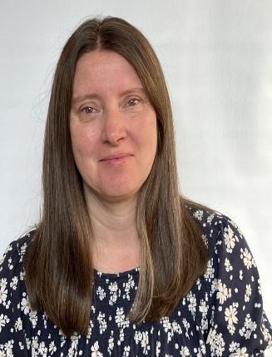 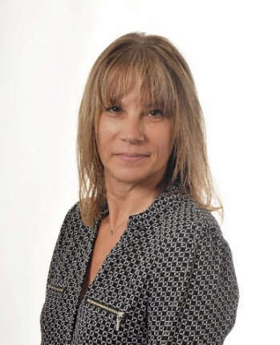 
Mrs Siu Lau Mrs Julie Jackson Mrs Kathryn Reynolds Miss Leona Heeney
(Learning Support Assistant) (Learning Support Assistant) (Learning Support Assistant) (Learning Support Assistant)   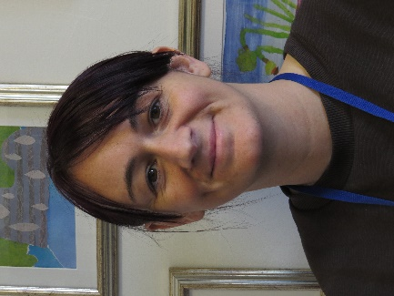 
Miss Helen Fitchett Mrs Anne Fearn Miss Diane Booth Mr Tibor Balogh
(Midday Assistant) (Midday Assistant) (Midday Assistant) (Site Manager)

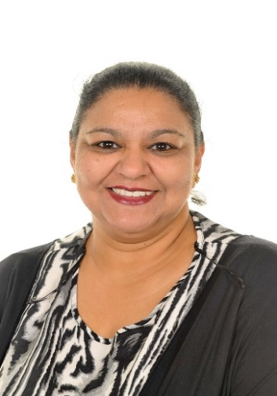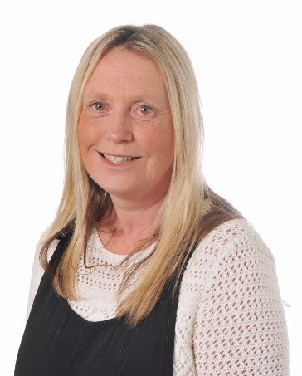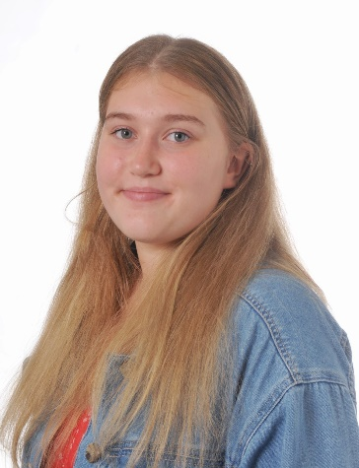
Mrs Ruth Share Mrs Ann Singh Mrs Joanne Aymes Miss Mia Share
(Squirrel Club Deputy Manager) (Midday Assistant/Playworker) (Playworker) ( Playworker)

