18th February 2022
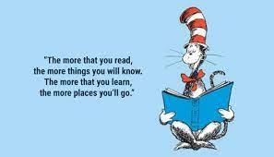
Dear Parents,
World Book Day Plans

This year we will be celebrating World Book Day on Friday 4th March. Our whole school theme is “Dr Suess” and so we encourage children and staff to dress up in this theme (e.g. wear red and white) or as characters from his stories (e.g. Cat in The Hat, The Grinch) !

We have invited into school “West End In Schools” who will be delivering dance workshops to “Bring Books to Life” with each class linked to the Dr Suess book “The Lorax”.

“Our Bringing Books to Life dance workshops give children a unique insight into books by using dance and movement to tell stories. During the dance workshop our choreographer will work with each class, developing responses to some of our most beloved children's books through language, movement and dance.”

The cost of this dance workshop is just £2.50 per child and we hope you will agree is a wonderful experience for children to immerse themselves fully in a quality story. Teachers will also plan a range of activities in class for the children to explore a Dr Suess book further.

We also have a book fair running in school the first week back on Tuesday 1st March and Wednesday 2nd March. You can pay for your books by cash or card using the QR code displayed at the fair. (You will need your card details present with you!)

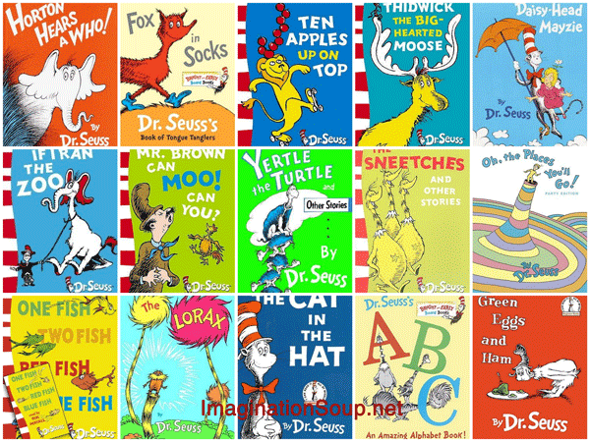
We look forward to another fun filled day this year and hope you will encourage your child to join in these celebrations. Please follow the link below to contribute to the costs of the dance workshop, without which, these exciting activities in school cannot continue to take place.

Cheshire East Payment Link

Yours Sincerely,
Miss Platt
Deputy Headteacher

