What I already know
Events happened before I was born
There have been changes to life over time
Some people are important to me
Some people who are important to others
Sarah Forbes Bonetta Timeline

1852 | Sarah was born (approximate date)
1848 | Sarah was captured with her parents by King of Dahomey during a slave hunt
1850 | When she was around eight years old, she was rescued by Captain Frederick E Forbes of the Royal Navy. She was presented to Queen Victoria
1851 | Sarah became very ill and went back to Africa.
1855 | Queen Victoria said Sarah had to return to England.
1862 | Sarah got married and moved to Africa. She had a daughter who she called ‘Victoria’ after Queen Victoria. Queen Victoria was the baby’s god mother
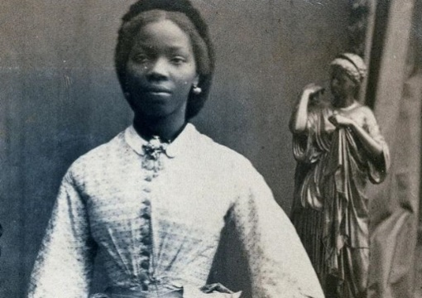
Vocabulary
Britain/British | 4 countries that make up Britain
captured | Taken against their will
empire | The countries around the world where they have the same monarch
missionary | A person sent on a religious mission, especially one sent to promote Christianity
monarch | Ruler of a country
queen | Female ruler of a country
significant | Someone or something that has made a difference to others and is important
slave | Someone who is captured and owned by a person who controls what they do
trade | Swapping something you don’t need for something you do can be in exchange for money
Key Questions
What do we mean by significance?
Who was Sarah Forbes Bonetta?
How will Sarah Forbes Bonetta be remembered?
Key Facts
Introduce the idea of significance, and how this might change over time.
Sarah Forbes Bonetta - we don't even know her real name - was an African princess, a slave in West Africa, a god-daughter of Queen Victoria, a wife, mother and missionary teacher.
Does that make her a Significant Individual in Victorian times? And today?
Final Activity
Design a statue or a memorial to Sarah Forbes Bonetta, or a museum display.
What are the parts of her story you want to emphasise? How are you going to present your finished work?

