What should I already know?  - I may have siblings that are younger than me.  - My parents and grandparents are older than me.  - Events happened before I was born  - Individuals that are significant e.g. Sarah Bonnett | What will I find out by the end of the unit?  - There was a time before my grandparents  were born. Life was very different then. People wore different clothes, travelled in different ways, children went to work and school was very different too.  - The Gregg family built Styal Mill with houses for the workers  - Styal Mill is near where I live and made cotton  - Samuel Gregg built Styal Mill by 1874  - Samuel and his wife Hannah built a community surrounding the mill, including a village for the workers, school and the Apprentice House; they even built their family home next door to the mill and developed the surrounding landscape into beautiful gardens.  - Some children worked in mills and were called child apprentices | Vocabulary  after later in time than, or behind in order  apprentice someone learning a job  before at an earlier time; in the past  century equal to one hundred years  chronology the order of events in time  differences the condition of being different from or not like  during throughout the entire time of  mill Building for making goods e.g. cotton  new having recently arrived, been produced, or come into being  now at this time or in these times  old having existed for many years; not new.  older having lived for many years  past having happened or gone by at an earlier time  present existing at this time; current  significant Somewhere that is important  similarity likeness  slightly a small amount; a little  technology devices which are the result of scientific knowledge being used for practical purposes.  then soon after; next  usually most common or expected  younger earlier stage of life
Historical Skills and Enquiry
- Create a timeline showing events, and then use words such as before, after, past, present, then and now to describe their chronology.
- Describe what life was like in Victorian times and what the similarities and differences are.
- Describe how clothes have changed - bring in pictures to show what your parents/carers and grandparents wore
- Describe how schools have changed over the last century
- Describe what home life was life in Victorian times
- Describe how transport has changed over the last century
- Describe how technology has changed over the last century

Samuel Gregg

 | 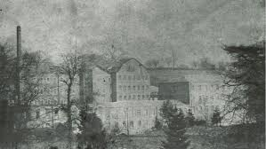

Victorian Times | Wartime Life | When your grandparents were little | When your parents/carers were little | Your childhood
Links with other subjects
PSHE – relationships, growing and changing
Geography – local area
Design Technology – looms, mills, manufacturing, changes in technology
Reading – finding information, extracting meaning, compare and contrast
Maths – time, ordering and sequencing

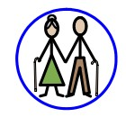
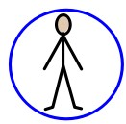
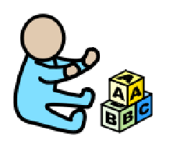

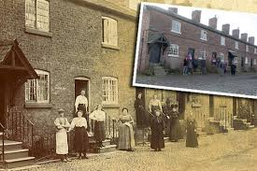

Key Concepts
Daily life  (Children at work) | Know the similarities and differences between times in the past and compare to their own experiences

