What I already know
- Greece is a country in the continent of Europe.
- The climate of Greece is slightly different to that of the UK.
- Human and physical geographical features of Greece.
- Information about the Egyptian civilisation.
- The Romans invaded Britain.
- The chronology of British history.
What will I know by the end of the topic?

- Greece was divided into city states (polis) that each had their own laws and way of life, but that all spoke the same language. Two of the most well-known city states are Athens and Sparta.
- In Athens, Greek styles of art, architecture, philosophy and theatre were developed - these helped shaped our modern society along with science, language and maths.
- Athens had a democratic government – this means that the people who lived there made decisions by voting, like we do in Britain.
- In Sparta, life was very different; all that was important was being able to defend Sparta in battle.
- The first Olympic games were held in 776 in the city-state Olympia.
- Religion was very important in ancient Greece. They were polytheists - they believed in different gods and goddesses that were in charge of different parts of their lives, such as a god of the sea and a goddess of wisdom. Temples were built in their honour and they featured heavily in the stories of Greek mythology.
- A polis consisted of an urban centre, often fortified and with a sacred centre built on a natural acropolis (citadel) or harbour.
Vocabulary
acropolis | the citadel of an ancient Greek city
archaeologist | someone who studies the past by exploring old remains
architecture | the art of planning, designing and constructing buildings
chronology | the order of events in time
circa | Latin meaning ‘around’. c. 800 BC means around 800 BC.
citadel | a strong building in or near a city, where people could shelter for safety
civilisation | a human society with its own social organisation and culture.
climate | the general weather conditions that are typical of a place
continent | a very large area of land that consists of many countries. Europe is a continent.
culture | activities such as the arts and philosophy, which are considered to be important for the development of civilisation
deity | a god or goddess
democracy | a fair political system where all adults vote for an elected government. This government then makes decisions on how to run the country.
empire | a number of individual nations that are all controlled by the government or ruler of one particular country
fertile | rich in nutrients to support the growth of many plants
invasion | to try and take over a place by force
merchant | a person who buys or sells goods in large quantities
military | relating to or belonging to the army
mythology | a group of myths, especially all the myths from a particular country, religion, or culture.
philosophy | the study or creation of theories about basic things such as the nature of existence, knowledge, and thought, or about how people should live
polis | an ancient Greek city-state
polytheists | the worship of or belief in more than one god
seafaring | working as a sailor or travelling regularly on the sea
society | people in general, thought of as a large organized group
trade | the activity of buying, selling, or exchanging goods or services
urban | belonging to, or relating to, a town or city
warfare | the activity of fighting a war

Alderley Edge Community Primary School - History
Topic: How Can We Know So Much About The Ancient Greeks? | Year: 4 | Strand: Civilisation
Historical enquiry skills I will develop
- Examine Greek artefacts (such as vases) and use these to make inferences about the past.
- Describe how Greek artefacts and ruins tell us about their culture, military, and religious beliefs.
- Describe how the Greek society has had an impact on modern society.
- Discuss the notion of democracy - compare the democratic process of ancient Greece with that of modern Britain.
- Examine the timeline of the Greek civilisation and consider where there was rapid change and where there was very little change. Explain why this may the case.
- Compare what was happening in the Greek civilisation with what was happening in Britain at the same time.
- Place the chronology of key events of the Greek civilisation on a time line with a chronology of the history of Britain. Where are the overlaps?
- Describe the ideas, beliefs and attitudes of all groups of people in the Greek civilisation.
- Compare the expansion of the Greek empire with that of the British Empire under Queen Victoria
Diagrams
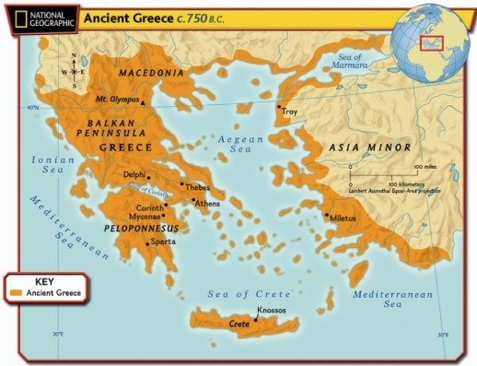
Greece is made up of the mainland and many islands.
- Its position by the sea meant that the Greeks were a seafaring people.
- City-states (polis) were created and trade happened between each of the cities.
- Greece is a warm country, but winds from the Mediterranean, and rains from the north, kept temperatures liveable and created fertile farming conditions.
