What I already know
- Significant individuals and achievements of the Ancient Greeks
- Significant individuals and achievements of the Ancient Greeks
- The chronology of British history

Vocabulary
acropolis | the citadel of an ancient Greek city
archaeologist | someone who studies the past by exploring old remains
architecture | the art of planning, designing and constructing buildings
chronology | the order of events in time
circa | Latin meaning ‘around’. c. 800 BC means around 800 BC.
citadel | a strong building in or near a city, where people could shelter for safety
civilisation | a human society with its own social organisation and culture.
continent | a very large area of land that consists of many countries. Europe is a continent.
culture | activities such as the arts and philosophy, which are considered to be important for the development of civilisation
deity | a god or goddess
democracy | a fair political system where all adults vote for an elected government. This government then makes decisions on how to run the country.
dynasty | a sequence of rulers from the same family,
empire | a number of individual nations that are all controlled by the government or ruler of one particular country
fertile | rich in nutrients to support the growth of many plants
invasion | to try and take over a place by force
merchant | a person who buys or sells goods in large quantities
military | relating to or belonging to the army
mythology | a group of myths, especially all the myths from a particular country, religion, or culture.
philosophy | the study or creation of theories about basic things such as the nature of existence, knowledge, and thought, or about how people should live
polis | an ancient Greek city-state
polytheists | the worship of or belief in more than one god
seafaring | working as a sailor or travelling regularly on the sea
society | people in general, thought of as a large organized group
trade | the activity of buying, selling, or exchanging goods or services
urban | belonging to, or relating to, a town or city
warfare | the activity of fighting a war
What will I know by the end of the topic?

- The civilisations of Ancient Egypt, Indus and Shang Dynasty in Ancient China
- Know the greatest achievement of each civilisation
- To know what each civilisation needed to have to function as a city
- How archaeology allowed us to learn about the past
- Know more in-depth knowledge about the Indus Valley civilisation
- Know that the different civilisations all started and finished at different times but there was one point when they were all building cities and developing their civilisations at the same time
- Understand the complexity of people’s lives, the process of change, the diversity of societies and relationships between different groups, as well as their own identity and the challenges of their time

Alderley Edge Community Primary School - History
Topic: What did the Ancient Civilisations Have in Common? | Year: 6 | Strand: Civilisation

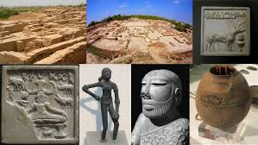
Historical enquiry skills I will develop
- Use secondary sources to find out information about the past
- Make comparisons across historical periods
- Ask perceptive questions, think critically, weigh evidence, sift arguments, and develop perspective and judgement
- Conduct an in-depth study of the Indus Valley or Shang Dynasty

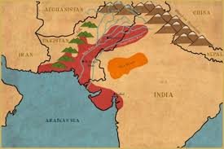
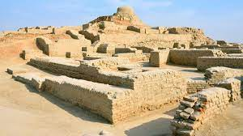
Mohenjo-Daro
Indus Valley

