 | Vocabulary
aerial view | a view from above
city | a city is a very large town. Manchester is a city.
factory | where goods are made in large quantities
farm | an area of land used to produce crops or to breed animals and livestock.
hill | a naturally raised area of land, which is not as high as a mountain.
house | a building designed for people to live in.
human geography | features of land that have been impacted by human activity
map | a drawing of a particular area such as a city, a country or a continent
market | a place where people gather to buy and sell goods
office | a building of rooms where business and work is carried out by office workers.
physical geography | natural features of land
river | a large, natural stream of fresh water that flows into the sea or a lake.
shop | a building in which goods are sold. For example, supermarkets, clothes shops and toy shops.
town | a large group of houses, shops and buildings where people live and work. Towns are larger than villages but smaller than cities. Alderley Edge is a village.
train station | a place on a railway line where trains stop for people to get on and off trains.
village | a small group of houses, perhaps with a few shops, that are often in the countryside.
 | What should I already know?
• | The village I live in is called Alderley Edge.
• | Alderley Edge is in England.
• | Alderley Edge is near Manchester.
 | Information about Alderley Edge and Manchester
• | Alderley Edge is a town.
• | It is near Manchester which is a city.
• | Manchester is larger than Alderley Edge and has more shops, offices and houses.
• | There are also factories in Manchester.
• | Alderley Edge has a site of special interest – The Edge.
• | There is a train station in Alderley Edge
• | There are many farms around Alderley Edge
Human Geographical Features
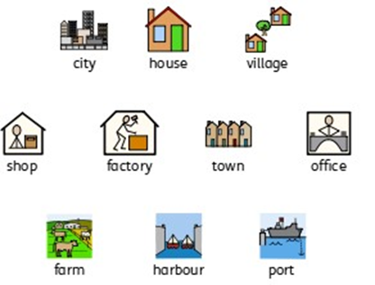
Alderley Edge Community Primary School
TOPIC: UK (Alderley Edge) | Strand: Place / Knowledge (Human and Physical) | Year 1

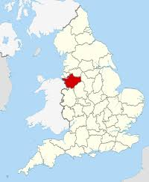
Manchester
Cheshire
London
Where is Alderley Edge?
Alderley Edge
 |  |  | What can I find in Alderley Edge?
• |  | shops:  supermarket  chemist  restaurants  estate agents
• |  | sports clubs and sports centres
• |  | The Edge
• |  | schools
• |  | houses
• |  | church
• |  | library
• |  | medical centre
• |  | farms
Geographical Skills and Fieldwork
- Go on a tour of the school using a map and then look at an aerial view photograph - can you label it to show where the different classrooms are?
- Take a walk around Alderley Edge using a map to help you. What symbols are on the map? What do they mean?
- Look at an aerial view photograph of Alderley Edge - can you label it using symbols and create a key?
- Can you draw a map that includes your house, the school and the park? Can you label your map or use symbols?
- Can you use words like near/far and right/left to describe where places are?
- Take a walk down Alderley Edge main street - what shops do you notice?
- Compare Manchester and Alderley Edge. How are they similar? How are they different?

Physical Geographical Features
