Alderley Edge Community Primary School
TOPIC: Comparing UK to non European area (China - Asia) | Strand: Place Knowledge / Human and Physical Geography | Year 2
What I should already know
- There are seven continents, including Asia and Europe, and five oceans.
- The village I live in is called Alderley Edge.
- Alderley Edge is in England, which is in the UK. The UK is in the continent of Europe.
- China is an example of a country that can be found in the continent of Asia.
Key Facts
- The United Kingdom is in Europe.
- China is in Asia.
- Europe and Asia are continents.
- The United Kingdom and China are countries.
- Both the UK and China are made up of villages, towns and cities.
- China is much larger than the UK.
- China and the UK have different climates. This means that the weather is generally different.
- Beijing is the capital city of China.
Geographical Skills and Fieldwork
- Use aerial photographs to compare Alderley Edge and Chinese village . What is the same? What is different?
- Use an atlas to find China and the UK. Can you give instructions on how to use an atlas?
- Contact pupils in schools in China. What questions do you want to ask them? What can you tell them about Alderley Edge?
Vocabulary
capital city | the city where the government sits. London is the capital city of England and the UK.
city | a large town. London is a city.
climate | weather that is typical of a place
continent | a very large area of land that consists of many countries. Europe is a continent.
country | an area of land that is controlled by its own government.
human features | features of land that have been impacted by human activity
humid | a climate that is very hot and damp
landscape | everything you can see when you look across an area of land, including hills, rivers, buildings, trees, and plants.
physical features | natural features of land
rainfall | the amount of rain that falls in a time period
seasons | main periods of the year that can have their own weather conditions
skyscrapers | a very tall building with many floors
temperature | a measure of how hot or cold something is
tourist | a person who is visiting a place for pleasure and interest, especially when they are on holiday.
town | a large group of houses, shops and buildings where people live and work. Towns are larger than villages but smaller than cities. Sudbury is a town.
vegetation | plants, trees and flowers
village | a small group of houses, perhaps with a few shops. Alderley Edge is a village.
Human Geographical Features of China
- In Beijing, people live in houses and apartments.
- There are tall buildings, which are called skyscrapers.
- Beijing also has many parks, museums, shopping malls and supermarkets.
- There is also a train stations and an airports.
- Many tourists visit China.
- China is famous for the Great Wall of China which is one of the only man made landmarks that can be seen from space.
- China has the largest population in the world.
- The official language is Mandarin but there are other languages too

Physical Geographical Features of China
- The 3 main rivers in China e.g. Yangtze, Huang he and Pearl rivers.
- There are mountains and flat plains
- The Himalayan mountains are in the south-west of china.
- China has different climates. The north is cold and dry and the south is warmer and wetter.
- There is a great flat plain in the north-west of China.

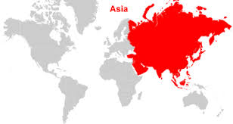

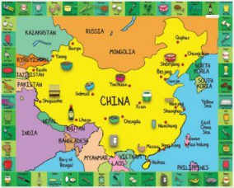
UK

