 | Vocabulary
aerial view | a view from above
city | a city is a very large town. Manchester is a city.
coast | Where land meets sea
farm | an area of land used to produce crops or to breed animals and livestock.
hill | a naturally raised area of land, which is not as high as a mountain.
human geography | features of land that have been impacted by human activity
Man made | Made by humans
map | a drawing of a particular area such as a city, a country or a continent
natural | Made but the plants, animals, weather
physical geography | natural features of land
river | a large, natural stream of fresh water that flows into the sea or a lake.
sand dunes | Large mounds of sand that are a habitat for vegetation and animals
sea | Large expanse of water with tides
town | a large group of houses, shops and buildings where people live and work. Towns are larger than villages but smaller than cities. Alderley Edge is a village.
village | a small group of houses, perhaps with a few shops, that are often in the countryside.
What should I already know?
The village I live in is called Alderley Edge
Alderley Edge is in England.
Alderley Edge is near Manchester.
Alderley Edge has shops, train station, school
Alderley Edge has a site of special interest – The Edge
Information about Alderley Edge and Formby
Alderley Edge is a town in Cheshire
Formby is a town near the sea in Merseyside
Alderley Edge has a site of special interest – The Edge
Alderley Edge has a site of special interest – The Sand Dunes
There is a train station in Alderley Edge and Formby
There are many farms around Alderley Edge and Formby
Formby is near the coast and has a beach
There are shops, B&S, hotels, caravan parks and guest houses for tourists

What will I know at the end of the topic?
That Formby is near the sea and Alderley Edge is in land

That there are things that are the same and things that are different between Alderley Edge and Formby

What is natural and what is man made in Formby

That tourists visit and go on holiday to Formby because it is near the sea

The type of shops and businesses in Formby meet the needs of the holiday makers

Alderley Edge Community Primary School
TOPIC: The Seaside (Contrasting Locality) | Strand: Place / Knowledge (Human and Physical) | Year 1

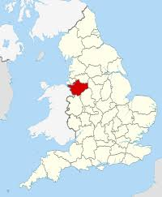
London
Formby
Manchester
Cheshire
Where is Formby?
Alderley Edge
What can I find in Formby?
shops:
supermarket
chemist
restaurants
estate agents
sports clubs and sports centres
National Trust – The Sand Dunes and Beach
schools
houses
church
library
medical centre
farms

Geographical Skills and Fieldwork
- Go on a tour of Formby using a map and then look at an aerial view photograph - can you label it to show where the different classrooms are?
- Look at an aerial view photograph of Formby - can you label it using symbols and create a key?
- Can you draw a map that includes your sea, the town and the sand dunes? Can you label your map or use symbols?
- Can you use words like near/far and right/left to describe where places are?
- Take a look at pictures of Formby high street main street - what shops do you notice?
- Compare Formby and Alderley Edge. How are they similar? How are they different?

Physical Geographical Features
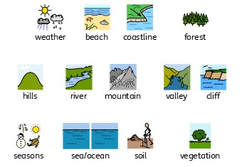
Human Geographical Features
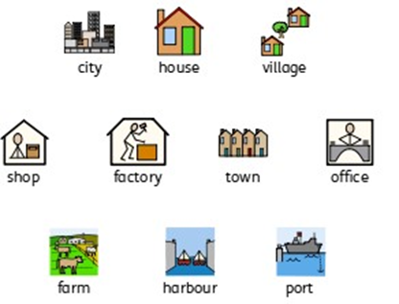

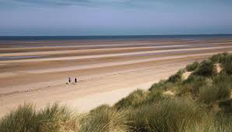
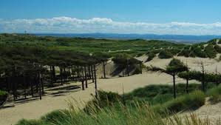
The Beach - Formby
National Trust - Formby

