Alderley Edge Community Primary School
TOPIC: Grasslands (temperate and tropical) | Strand: Place / Knowledge (Biomes) | Year 5
What should I already know?
- The seven continents and five oceans.
- The names of some key rivers around the world including the Thames and the Nile.
- The main biomes and climate zones around the world, including tropical, temperate, polar, desert and Mediterranean
- The climate of South America and how it differs to the UK.
- The climate of places is affected by their location (e.g. the equator, Tropics).
- The effects of climate change and pollution on the Earth.
- Which good some countries trade, and Cheshire’s biggest exports.
 | Vocabulary
biome | a natural area of the living world which has its own climate, vegetation and animals
climate | the general weather conditions that are typical of a place
climate change | changes in the earth’s climate, especially the gradual rise in temperature, as a result of human activity
climate zone | sections of the Earth that are divided according to the climate. There are three main climate zones; polar, temperate and tropical.
deforestation | if an area is deforested, all the trees there are cut down
distribution | delivering goods to a number of places
economy | A country's economy is the wealth that it gets from business and industry
equator | an imaginary line around the middle of the Earth at an equal distance from the North Pole and the South Pole.
export | To export products or raw materials means to sell them to another country
flora | plants
Food chain | The consumption and transfer of energy between plant and animals
fauna | animals
grassland | Large expanses of grass with little other large vegetation
import | To import products or raw materials means to buy them from another country for use in your own country
global | something that happens in all parts of the world or affects all parts of the world
natural resources | the land, forests, energy sources and minerals existing naturally in a place that can be used by people
pollution | the process of polluting water, air, or land, especially with poisonous chemicals
sustainability | to maintain at a steady level without exhausting natural resources or causing severe environmental damage
temperate | Biome that does not have extremes of hot or cold
tropics | parts of the world that lie between two lines of latitude, the Tropic of Cancer, 23½° north of the equator, and the Tropic of Capricorn, 23½° south of the equator.  The tropics have a humid climate, where the weather is hot and damp.
vegetation | plants, trees and flowers

Geographical Skills and Fieldwork
- Use atlases, maps and aerial photographs to find grasslands and explain what the climate is like there. Explain why grasslands cannot be found in the UK.
- Label maps to show where grasslands can be located.
- Compare the average rainfall in different climate zones, including the grassland, and draw a graph to represent this.
- Compare the sizes of different grasslands and represent them in a table.
- Explain how the vegetation and animal life changes in the different layers of the rainforest.
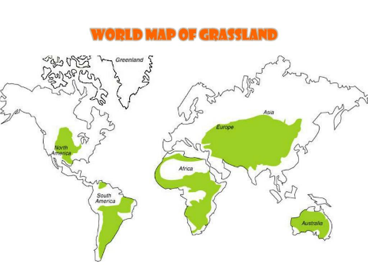
- Investigate the effects of climate change and pollution on grasslands.
- Explain sustainability and the role grasslands play

What will I know at the end of the topic?
- Grassland habitats can be found in many places around the world, and in a variety of climates.
- They are sometimes called other names, such as prairies, savannahs, steppes or pampas, depending on where in the world they are and the sort of climate there.
- Animals have adapted to the fact that grasslands don’t have many places to hide from predators by making homes in the ground, or by being tall enough to see over high grasses and shrubs.
- Grassland habitats can be found on more than 40% of the land on Earth. They are wide, open areas where mostly grass and flowers grow.
- Grassland habitats are very common, and there are many different kinds depending on the sort of climate they’re found in.
- Two main kinds of grasslands are tropical and temperate. Tropical grasslands are warmer than temperate grasslands.
- Tropical grasslands are located between the near the equator, and they stay pretty hot all year long. Savannahs in Africa are tropical grasslands.
- Temperate grasslands are located further away from the equator in both the northern and southern hemispheres. They can get very cold in the winter.
- Grasslands can be good for growing crops and feeding livestock, so many grasslands have been used for farming. This means that grassland animals can’t live there anymore, though.
- Grassland habitats get enough rain for grass to grow and cover the ground, but they don’t have the right rain and other conditions for trees to grow.
- The grass found in grassland habitats can be different lengths depending on exactly how much rainfall there is. For instance, tall grass will grow where there’s a lot of heat and moisture. In grasslands where it can be colder and drier, the grass will be short.
- A huge variety of animals and insects live in grassland habitats.
