 | Vocabulary
aerial view | a view from above
city | a city is a very large town. Manchester is a city.
factory | where goods are made in large quantities
farm | an area of land used to produce crops or to breed animals and livestock.
hill | a naturally raised area of land, which is not as high as a mountain.
house | a building designed for people to live in.
human geography | features of land that have been impacted by human activity
map | a drawing of a particular area such as a city, a country or a continent
market | a place where people gather to buy and sell goods
office | a building of rooms where business and work is carried out by office workers.
physical geography | natural features of land
river | a large, natural stream of fresh water that flows into the sea or a lake.
shop | a building in which goods are sold. For example, supermarkets, clothes shops and toy shops.
town | a large group of houses, shops and buildings where people live and work. Towns are larger than villages but smaller than cities. Alderley Edge is a village.
train station | a place on a railway line where trains stop for people to get on and off trains.
village | a small group of houses, perhaps with a few shops, that are often in the countryside.
 | What should I already know?
• | The village I live in is called Alderley Edge.
• | Alderley Edge is in England.
• | Alderley Edge is near Manchester.
 | Information about Alderley Edge and Manchester
• | Alderley Edge is a town.
• | It is near Manchester which is a city.
• | Manchester is larger than Alderley Edge and has more shops, offices and houses.
• | There are also factories in Manchester.
• | Alderley Edge has a site of special interest – The Edge.
• | There is a train station in Alderley Edge
• | There are many farms around Alderley Edge
Geographical Skills
- Use aerial photographs to compare Alderley Edge, Manchester and London. What is the same? What is different?
- Use a map to find Manchester, London and Alderley Edge.
- Contact pupils in schools in London. What questions do you want to ask them? What can you tell them about Alderley Edge?
Alderley Edge Community Primary School
TOPIC: Cities | Strand: Place / Knowledge (Human and Physical) | Year 2

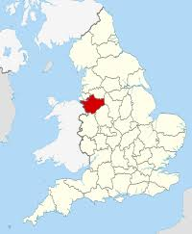
Manchester
Cheshire
London
Where is Alderley Edge and London?
Alderley Edge
 | HUMAN FEATURES | PHYSICAL FEATURES
ALDERLEY EDGE | 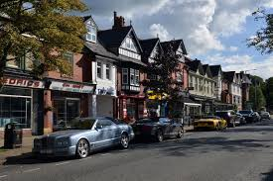  Some shops and offices  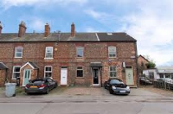  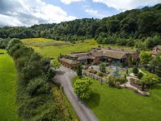  Some houses  Some farms  A train station | 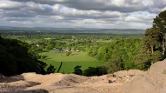  The Edge at Alderley Edge  Tourists visit the Edge  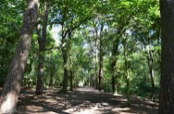  Woodland
LONDON | Many houses, shops, offices, apartments and roads  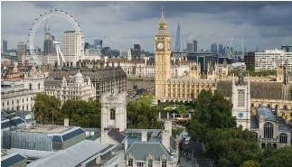  Many skyscrapers  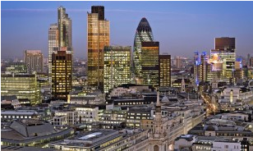  Five airports  Over 200 train stations  Famous buildings such as Big Ben, the London  Eye, the Houses of Parliament, Buckingham Palace, Tower Bridge. This means that there are lots of tourists.  Some ports | 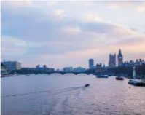  River Thames  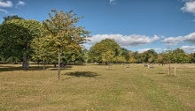  Some hills and vegetation
Physical Geographical Features
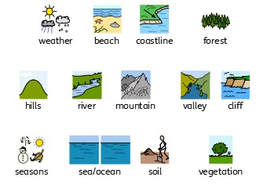

Human Geographical Features
