Alderley Edge Community Primary School
TOPIC: South America (Brazil) | Strand: Place Knowledge / Human and Physical Geography | Year 6
What should I already know?
- The village I live in is called Alderley Edge, which is in Cheshire.
- There are villages and towns in Cheshire but none are coastal.
- Cheshire is in England, which is a country. England, which is in the United Kingdom, is in the continent of Europe.
- The seven continents (including North and South America) and five oceans.
- Features of regions that lie on and between the tropics.
- The characteristics of countries that can be found in North and South America, such as the United States of America
- The human and physical characteristics of California.

Vocabulary
architecture | planning, designing, and constructing buildings.
canyon | a long, narrow valley with very steep sides
climate | the general weather conditions that are typical of a place
coastal | an area of land close to the sea
compass points | any of the main points of a compass: north, south, east, west, north-east, north-west, south-east, south-west
continent | a very large area of land that consists of many countries. Europe is a continent.
elevation | The elevation of a place is its height above sea level
empire | a number of individual nations that are all controlled by the government or ruler of one particular country
equator | an imaginary line around the middle of the Earth at an equal distance from the North Pole and the South Pole.
export | goods that are sold to other countries
fertile | rich in nutrients to support the growth of many plants
human feat. | features of land that have been impacted by human activity
metropolis | largest, busiest, and most important city in a country or region
migration | movement from one place to another in order to settle there
peninsula | a piece of land almost surrounded by water
physical feat. | natural features of land
precipitation | rain, snow, or hail
temperate | a place which is never extremely hot or extremely cold
tourist | a person who is visiting a place for pleasure and interest, especially when they are on holiday.
trade | the activity of buying, selling or exchanging goods and services
tropics | parts of the world that lie between two lines of latitude, the Tropic of Cancer, 23½° north of the equator, and the Tropic of Capricorn, 23½° south of the equator.  The tropics have a humid climate, where the weather is hot and damp.
weather | the condition of the atmosphere in one area at a particular

What I will know by the end of the unit?
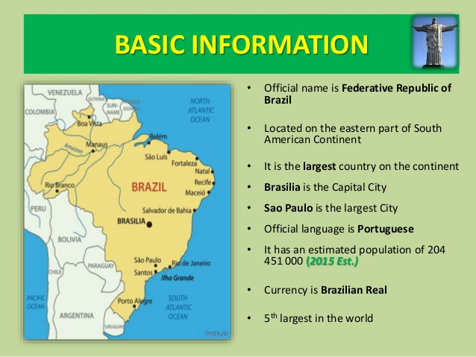
- Brazil's physical features are characterized by its highlands, plateaus and river basins.
- The region is not mountainous
- The defining feature of Brazil is the Amazon River basin, which covers more than 60 percent of the country.
- It has a tropical climate
- The Brazil sits on top of the equator.
- Its coastline is on the Atlantic Ocean
- It borders many South American countries including Venezuela, Bolivia and Peru

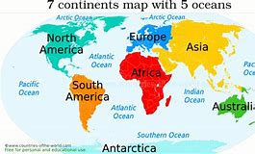

Brazil
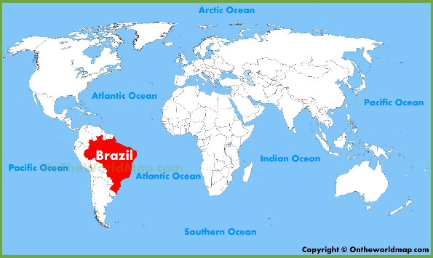
United Kingdom

Features of Cheshire and Brazil
 | Human | Physical
Cheshire | Cheshire has many villages (such as Alderley Edge) and towns (such as Macclesfield). The main city is Chester  Main Industries: Cheshire has many farms and is famous for the farming trade – Cheshire potatoes, dairy  Natural Resources: Cheshire has salt mines  Cheshire is famous for Cheshire Cheese  Historically Macclesfield was famous for silk  Other industries include cars (e.g. Bentley in Crewe) and tourism | Main rivers include the Mersey and Dee. River Bollin, in Wilmslow, is a tributary to the River Mersey into the Irish Sea  Cheshire has a lot of sandstone which is mined  Highest point – Shining Tor on the border with Derbyshire  The landscape is green as there are many fields.  The climate is mild. The summers are warm and the winters are cool.  Cheshire's natural hazards include floods
Brazil | Major Industries: textiles, shoes, chemicals, lumber  Agricultural Products: coffee, soybeans, wheat, rice, corn, sugarcane, cocoa, citrus; beef  Natural Resources: timber, iron, gold  Major Exports: iron ore, footwear, coffee  Language: Portuguese | Size: slightly smaller than the US  Continent: South America  Land: mostly flat to rolling lowlands in north; some plains, hills, mountains, and narrow coastal belt  Highest Point: Pico da Neblina 3,014 m  Climate: mostly tropical, but temperate in south  Major Cities: BRASILIA (capital) Sao Paulo; Rio de Janeiro  Major Landforms: Tropical rainforest of the Amazon Basin  Major Bodies of Water: Amazon River; Atlantic Ocean
Geographical Skills and Fieldwork
- Use aerial photographs to compare Cheshire in the UK and Brazil in South America. What is the same? What is different?
- Identify and describe how the physical features affect the human activity within a location.
- Study physical maps of Brazil and label them to show the different regions. Use this knowledge to explain the land-use patterns of Brazil.
- Explain how the human geography of a region of Brazil (such as San Paulo or Amazon Basin) has changed over the years.
- Study tourism and migration patterns of Brazil. Research which parts of Brazil generate the most tourism and explain the reasons why.
- Create a Venn diagram to compare similarities and differences between a region of Brazil and a region in North and South America and understand the reasons for these.
- Analyse, interpret and plot graphs that show variations in temperatures across the year in different parts of Brazil (e.g. coasts, forests, flatlands)

