Alderley Edge Community Primary School
TOPIC: CONTRASTING LOCALITY ~ PENSARN | Strand: Place Knowledge / Human and Physical Geography | Year 6
What should I already know?
- The village I live in is called Alderley Edge, which is in Cheshire.
- There are villages and towns in Cheshire but none are coastal.
- Cheshire is in England, which is a country. England, which is in the United Kingdom, is in the continent of Europe.
- The capital cities of the four countries that make up the United Kingdom and their characteristics.
- The surrounding seas of the United Kingdom.
- Land-use patterns in the local area and how they have changed over time.
- The terms urban and rural and use them to describe areas of the UK.
- How to locate places using four figure grid references.
- How to identify features such as hills, mountains, coasts and rivers on a map.

Largest cities of the UK (by population)*
City | Approximate  Population
Greater London | 8,674,000
Greater  Manchester | 2,756,000
West Yorkshire | 2,282,000
North East | 1,957,000
Glasgow | 1,804,000
Liverpool | 1,525,000
Cardiff | 1,505,000
*Office for National Statistics - Population

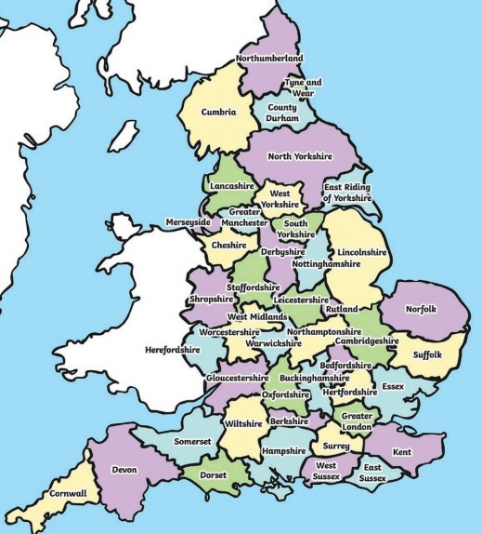
Newcastle
London

Cambridge

Manchester

Plymouth

Bristol

Liverpool

Birmingham

Cardiff
Pensarn Harbour
Geographical Skills and Fieldwork
- Use aerial photographs to compare Alderley Edge in Cheshire and Pensarn in Gwynedd. What is the same? What is different?
- Identify and describe how the physical features affect the human activity within a location.
- Study physical maps of Wales and label them to show the different regions. Use this knowledge to explain the land-use patterns of Wales.
- Explain how the human geography of a Wales (such as Llandudno or Ffestiniog) has changed over the years.
- Carry out landuse surveys of Pensarn and map, draw comparisons with Alderley Edge
- Study tourism and migration patterns of Wales. Research which parts of Wales generate the most tourism and explain the reasons why.
- Create a Venn diagram to compare similarities and differences between a Cheshire and a Gwynedd.
- Analyse, interpret and plot graphs that show variations in temperatures across the year in different parts of British Isles including Cheshire and Gwynedd
What I will know by the end of the unit?
- The main areas of human, physical and economic geographical features of Pensarn and contrast to Alderley Edge
- Create a key using symbols to show what different features are.
- Study Ordnance Survey topographical maps to plot land use patterns and features of counties of the UK
- Research how the population of Alderley Edge has changed over time. Present this in a graph. Compare this to a similar graph showing the population of Pensarn.
- Compare urban and rural areas using six-figure grid references.
- Compare different sources for population numbers. Which is the most reliable? Why is it hard to measure population?

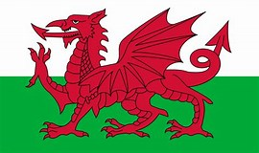
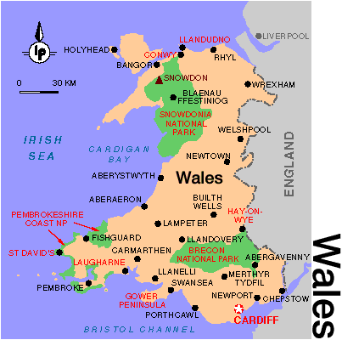

Vocabulary
architecture | planning, designing, and constructing buildings.
canyon | a long, narrow valley with very steep sides
climate | the general weather conditions that are typical of a place
coastal | an area of land close to the sea
compass points | any of the main points of a compass: north, south, east, west, north-east, north-west, south-east, south-west
continent | a very large area of land that consists of many countries. Europe is a continent.
cottage industry | Business or manufacturing carried on in peoples homes
elevation | The elevation of a place is its height above sea level
empire | a number of individual nations that are all controlled by the government or ruler of one particular country
equator | an imaginary line around the middle of the Earth at an equal distance from the North Pole and the South Pole.
export | goods that are sold to other countries
fertile | rich in nutrients to support the growth of many plants
human feat. | features of land that have been impacted by human activity
metropolis | largest, busiest, and most important city in a country or region
migration | movement from one place to another in order to settle there
peninsula | a piece of land almost surrounded by water
physical feat. | natural features of land
precipitation | rain, snow, or hail
temperate | a place which is never extremely hot or extremely cold
tourist | a person who is visiting a place for pleasure and interest, especially when they are on holiday.
trade | the activity of buying, selling or exchanging goods and services
tropics | parts of the world that lie between two lines of latitude, the Tropic of Cancer, 23½° north of the equator, and the Tropic of Capricorn, 23½° south of the equator.  The tropics have a humid climate, where the weather is hot and damp.
weather | the condition of the atmosphere in one area at a particular
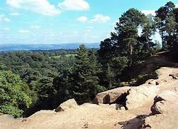
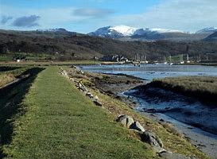
Features of Alderley Edge and Pensarn Harbour

 | Human | Physical
Alderley Edge | Cheshire has many villages (such as Alderley Edge) and towns (such as Macclesfield). The main city is Chester  Main Industries: Cheshire has many farms and is famous for the farming trade – Cheshire potatoes, dairy  Natural Resources: Cheshire has salt mines  Cheshire is famous for Cheshire Cheese  Historically Macclesfield was famous for silk  Other industries include science (Astra Zenica), construction and lesiure  Aldelrey Edge grew as a settlement due to the development of the railway in Victorian England and relocation of mill owners | Main rivers include the Mersey and Dee. River Bollin, in Wilmslow, is a tributary to the River Mersey into the Irish Sea  Cheshire has a lot of sandstone which is mined  Highest point – Shining Tor on the border with Derbyshire  The landscape is green as there are many fields.  The climate is mild. The summers are warm and the winters are cool.  Cheshire's natural hazards include floods
Pensarn Harbour | Major Industries: farming, tourism, slate mining, cottage industries  Agricultural Products: lamb, beef, poultry  Natural Resources: timber, wind farms, slate  Major Exports: slate, lamb,  Language: Welsh / English | Size: much smaller than Alderley Edge  Continent: Europe  Land: mountainous (Snowdonia National Park) and coastal  Highest Point: Mount Snowdon, 1085  Climate: oceanic, temperate and cool  Major Cities: CARDIFF (capital) Swansea; Bangor  Major Landforms: Snowdonia Mountain Range  Major Bodies of Water: Irish Sea

