Alderley Edge Community Primary School
TOPIC: Fair Trade | Strand: Human and Physical Geography | Year 6
Vocabulary
biome | a natural area of the living world which has its own climate, vegetation and animals
climate | the general weather conditions that are typical of a place
climate change | changes in the earth’s climate, especially the gradual rise in temperature, as a result of human activity
climate zone | sections of the Earth that are divided according to the climate. There are three main climate zones; polar, temperate and tropical.
cocoa | The plant from which cocoa pods are harvested
deforestation | if an area is deforested, all the trees there are cut down
distribution | delivering goods to a number of places
economy | A country's economy is the wealth that it gets from business and industry
equator | an imaginary line around the middle of the Earth at an equal distance from the North Pole and the South Pole.
export | To export products or raw materials means to sell them to another country
Fair Trade | An organisation set up to protect the rights of workers, farmers and the environment
Food miles | The total distance travelled by the whole product
import | To import products or raw materials means to buy them from another country for use in your own country
global | something that happens in all parts of the world or affects all parts of the world
natural resources | the land, forests, energy sources and minerals existing naturally in a place that can be used by people
manufacture | To create or make something from raw materials
palm oil | a yellow oil which comes from the fruit of certain palm trees and is used in making soap and sometimes as a fat in cooking
pollution | the process of polluting water, air, or land, especially with poisonous chemicals
supply chain | the entire process of making and selling goods, including every stage from the supply of materials and the manufacture of the goods through to their distribution and sale
sustainability | to maintain at a steady level without exhausting natural resources or causing severe environmental damage
trade | the activity of buying, selling, or exchanging goods or services
trade route | a route, often covering long distances, that is used by traders
tropics | parts of the world that lie between two lines of latitude, the Tropic of Cancer, 23½° north of the equator, and the Tropic of Capricorn, 23½° south of the equator.
vegetation | plants, trees and flowers
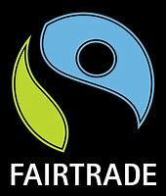
What I should already know?
- The seven continents and five oceans.
- The names of some key rivers around the world including the Thames and the Nile.
- The main biomes and climate zones around the world, including rainforests.
- The climate of South America and how it differs to the UK.
- Some of the human and physical features of Brazil.
- The climate of places is affected by their location (e.g. the equator, Tropics).
- The effects of climate change and pollution on the Earth.
- What trade is and the advantages and disadvantages
- Which good some countries trade, and Cheshire’s biggest exports.
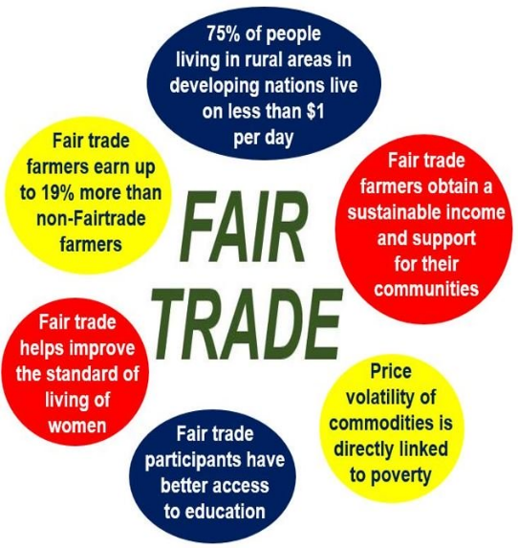
Geographical skills and fieldwork
- Use atlases, maps and aerial photographs to find rainforests and explain what the climate is like there. Explain why rainforests cannot be found in the UK.
- Label maps to show where cocoa can grow and link to rainforests can be located.
- Compare the average rainfall in different climate zones, including the rainforest, and draw a graph to represent this.
- Investigate the natural resources, such as palm oil, coffee and cocoa, and the role they play in trade routes.
- Describe the fair trade process for some products
- Follow a product from the plant through the global supply chain
- Explain sustainability and the role fair trade can play

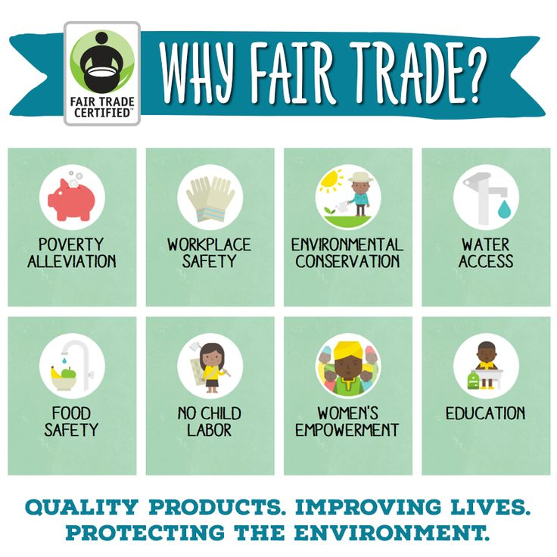
What will I know by the end of the unit?
- Where the main producers of cocoa are in the world
- That not all people are treated fairly and can be exploited
- The positives and negatives of Fair Trade
- That the cheaper costs of products may have negative consequences
- The impact of international trade on the local economy and lived of local people
- The impact of international trade on the environment
- The benefits of international trade
- As consumers we have rights and make choices

